**Assignment 10: Data Preparation using OpenRefine Tool**

**Task 1: Download and Install OpenRefine software:**

To install OpenRefine software open URL - <https://openrefine.org/download.html>. Choose the OS of your workstation on which you are going to work.

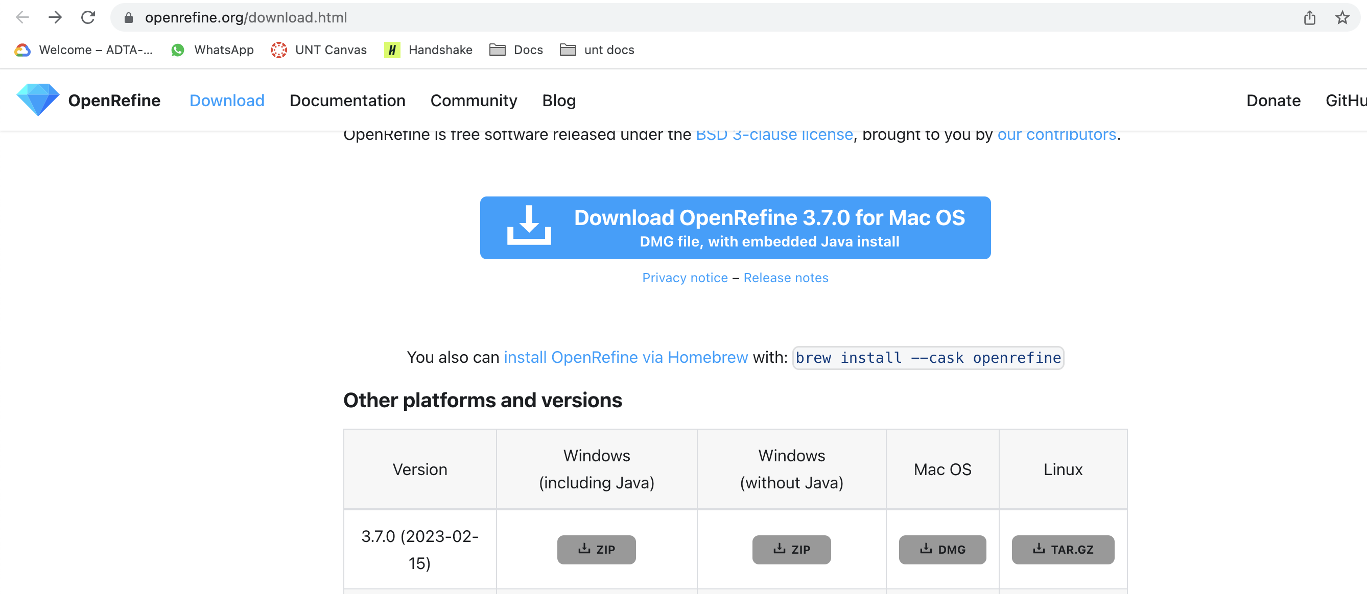

Hang on! it takes few moments to download into your machine.

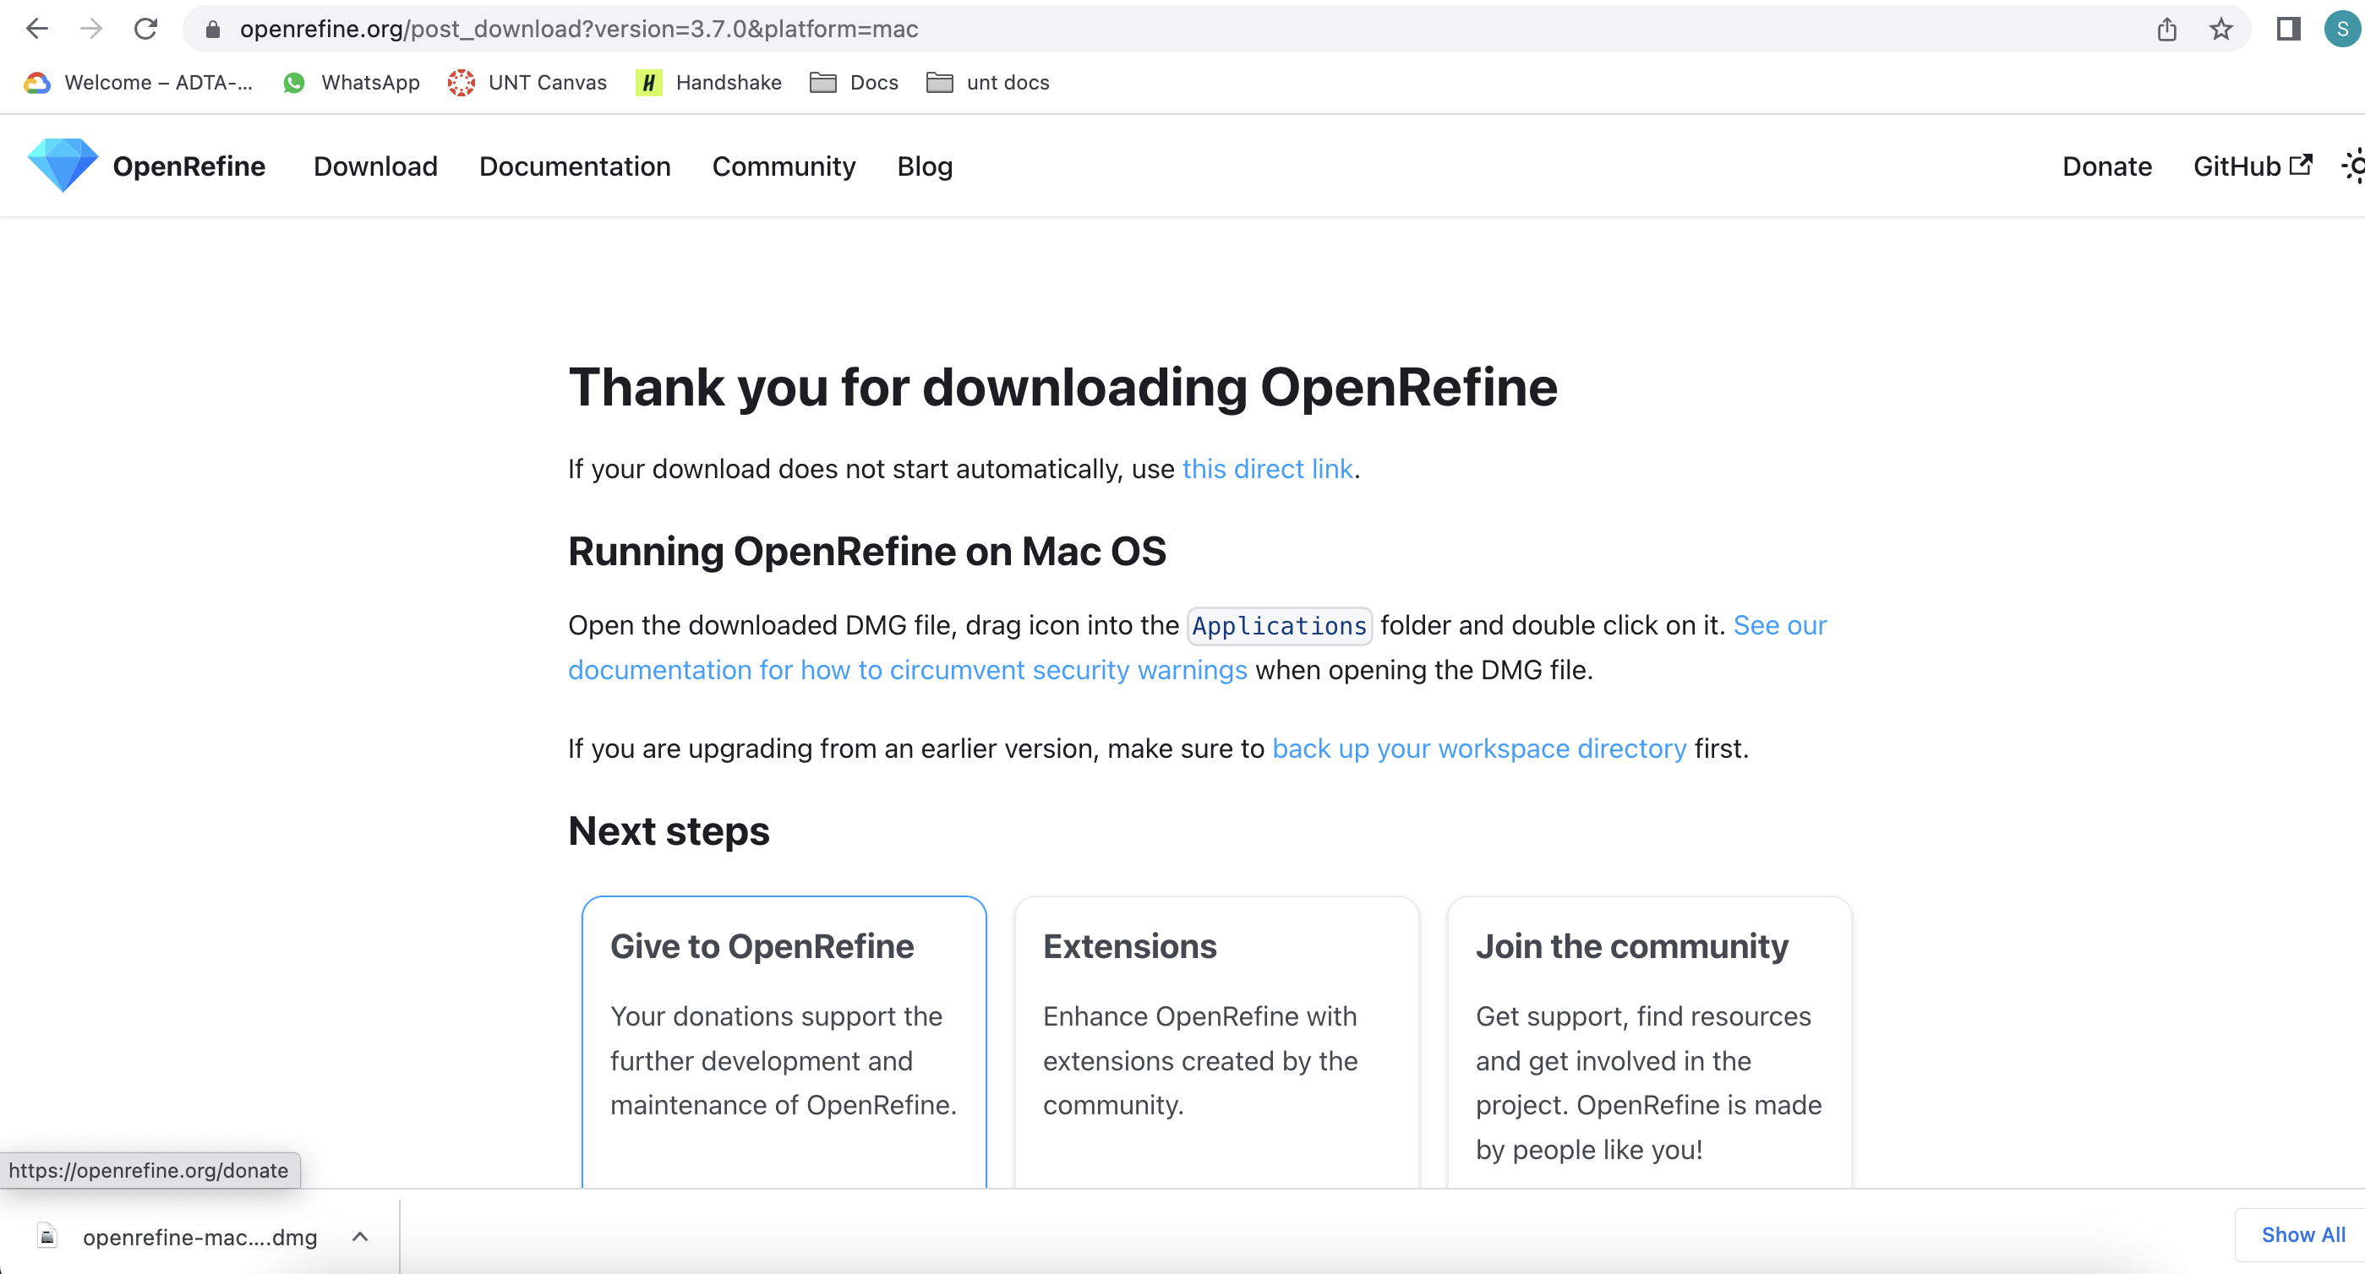

Once the download complete, you can install it on your machine.



**Task 2: Open OpenRefine tool**

Once you click on OpenRefine icon it will open OpenRefine tool at address (http://127.0.0.1:3333/) on Google Chrome. 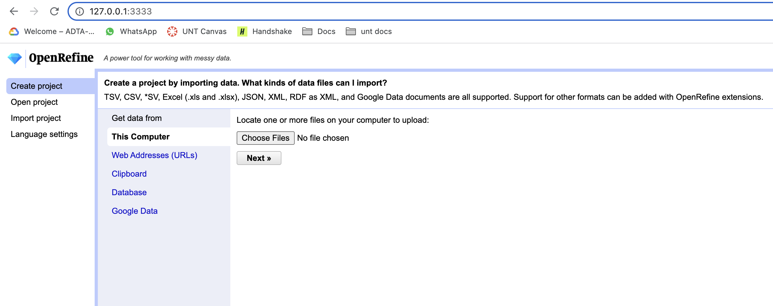

**Task 3: Create Project and Upload data**

Now, download the data consumer_Complaints.csv from modules section in canvas.

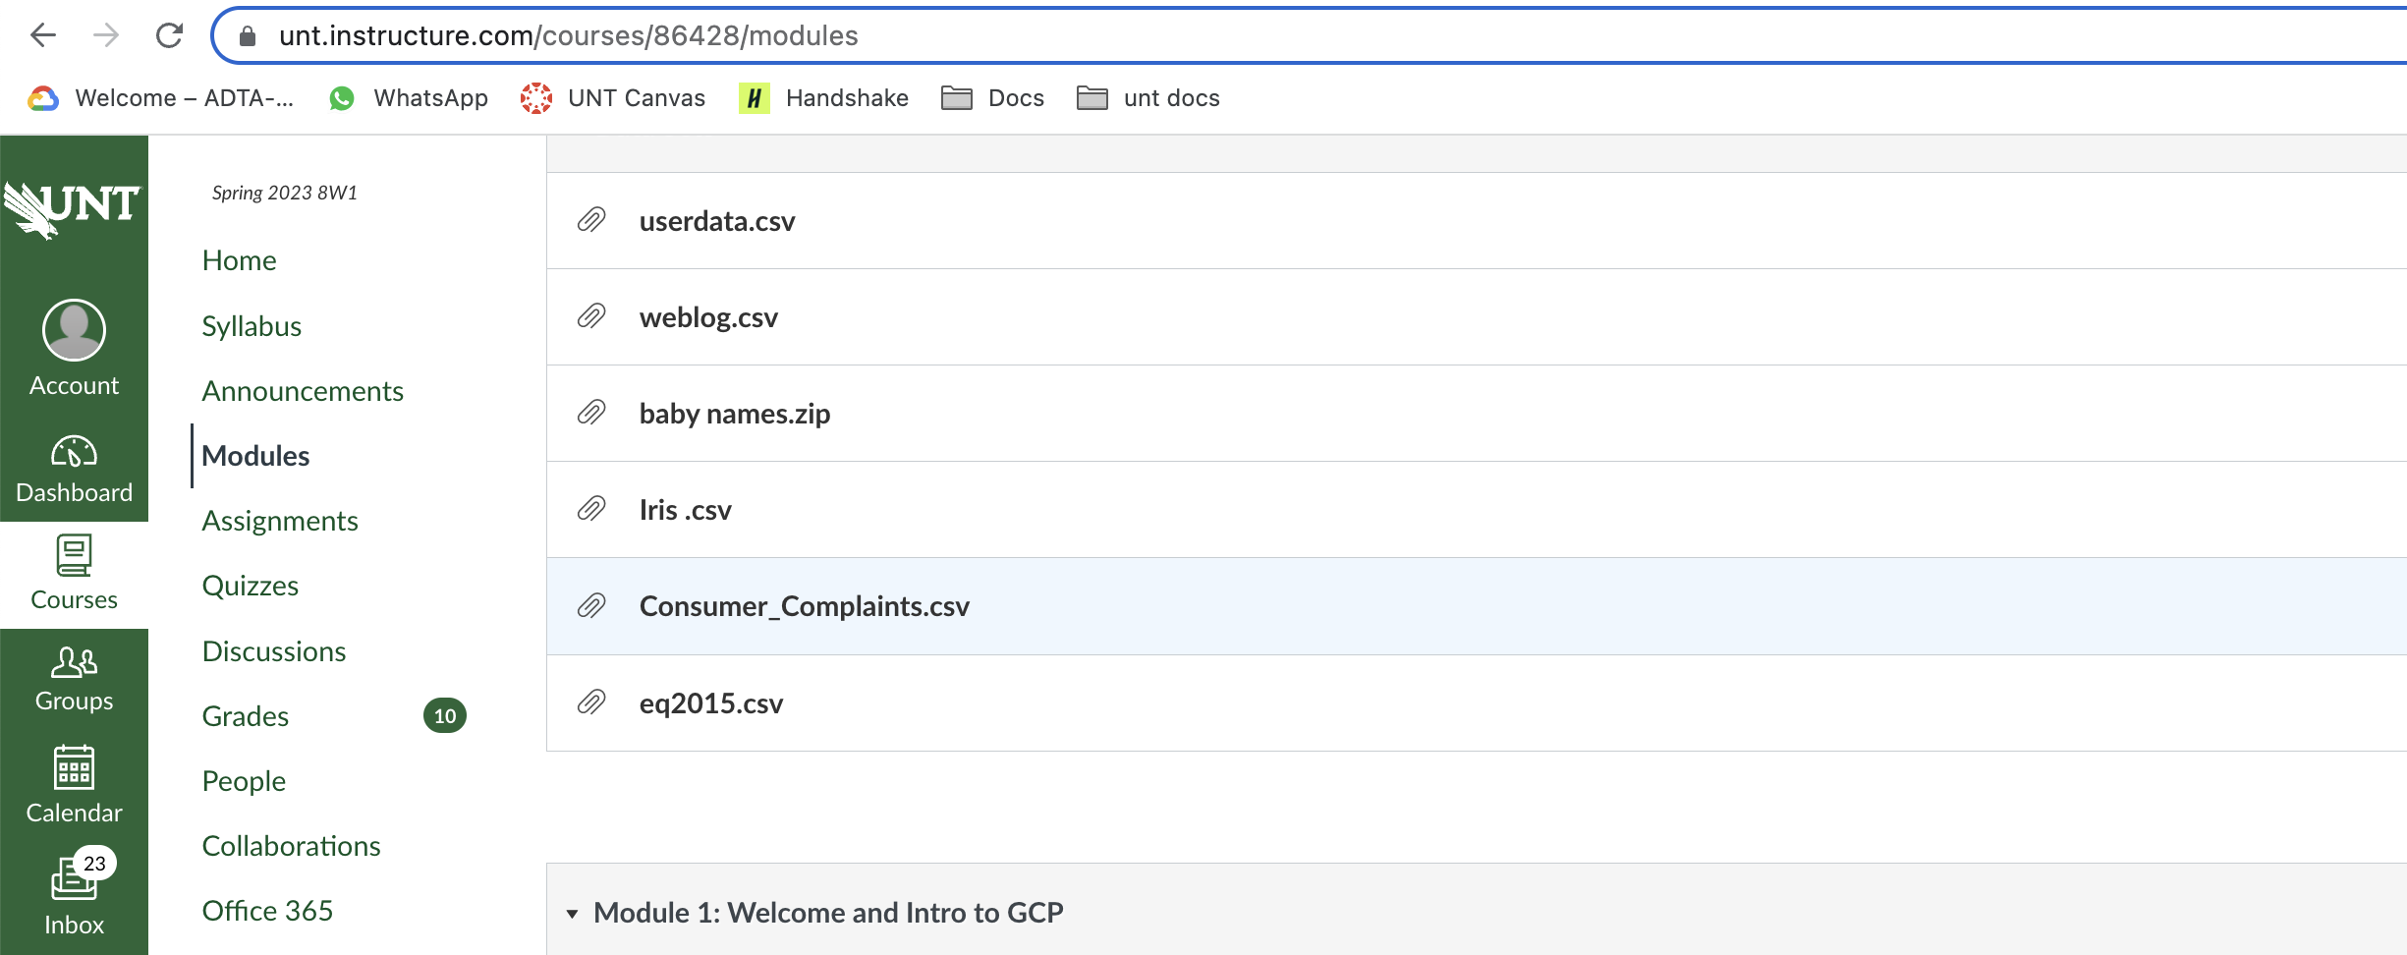

Go to OpenRefine tool in browser and click on “choose Files” button and select above downloaded data from files and click next. Data gets uploaded into the OpenRefine tool.

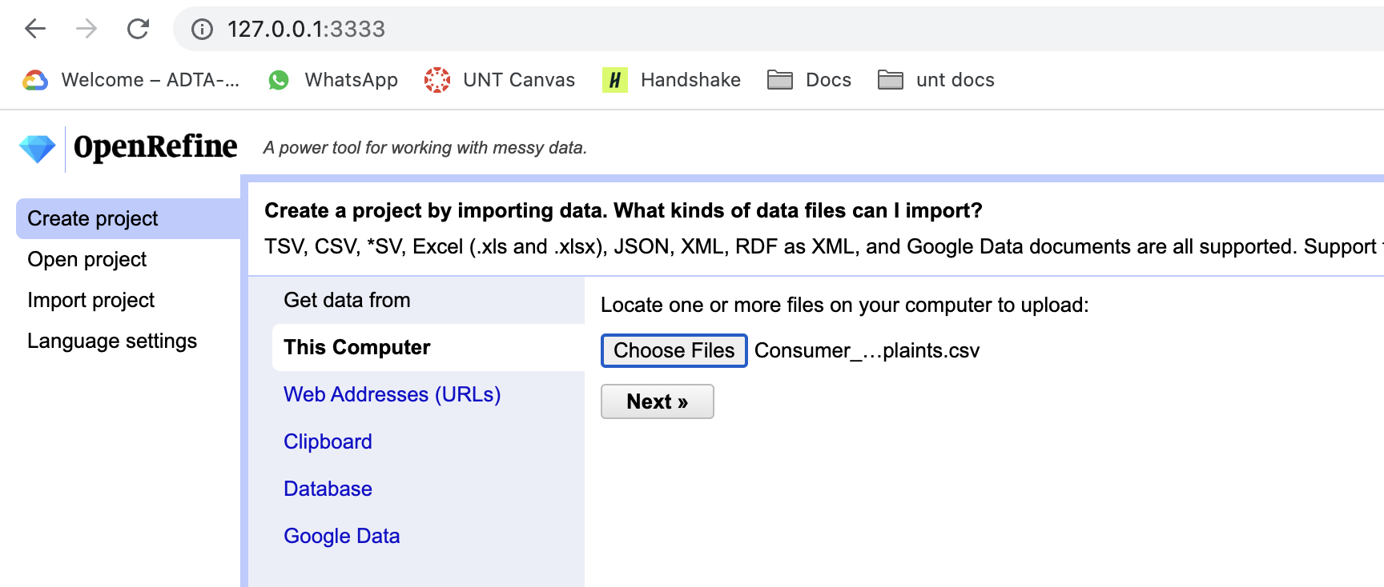

Now click on “Create Project” at the top right corner of the screen keeping all configurations as it is.

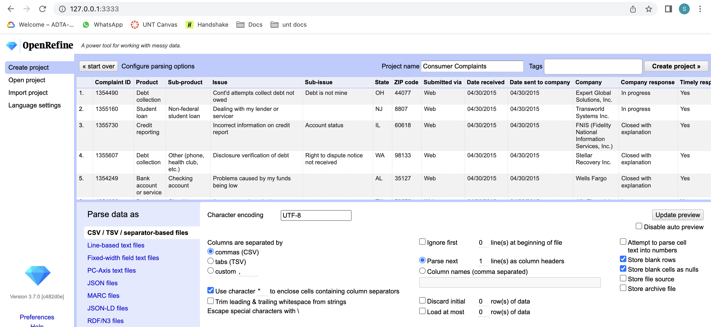

After few moments, your tool is ready to perform data operations.

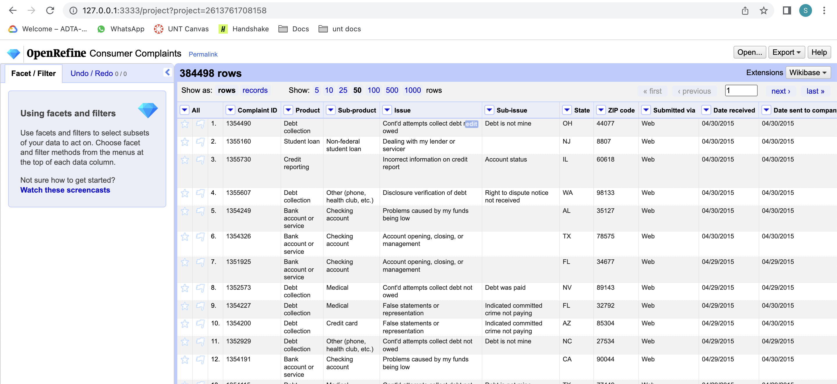

**Task 4: Check States and Text Facets**

Click on drop down at Zip code column, select Facet and click on “Text Facet”.

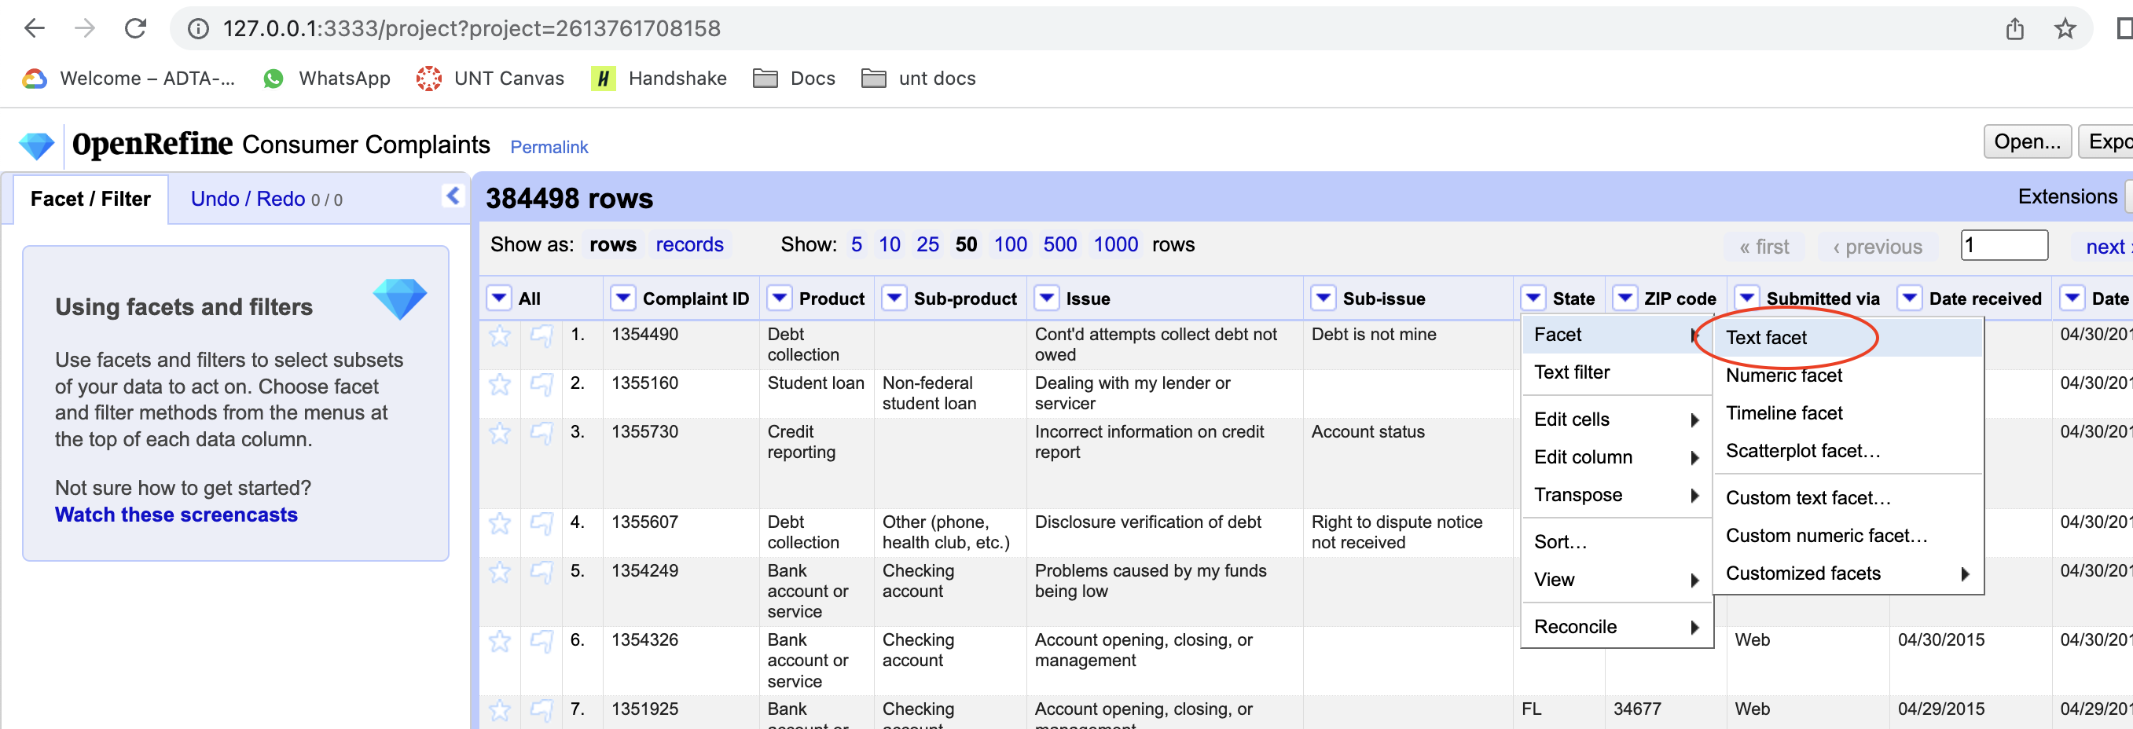

You will see unique values of Zip code with their counts.

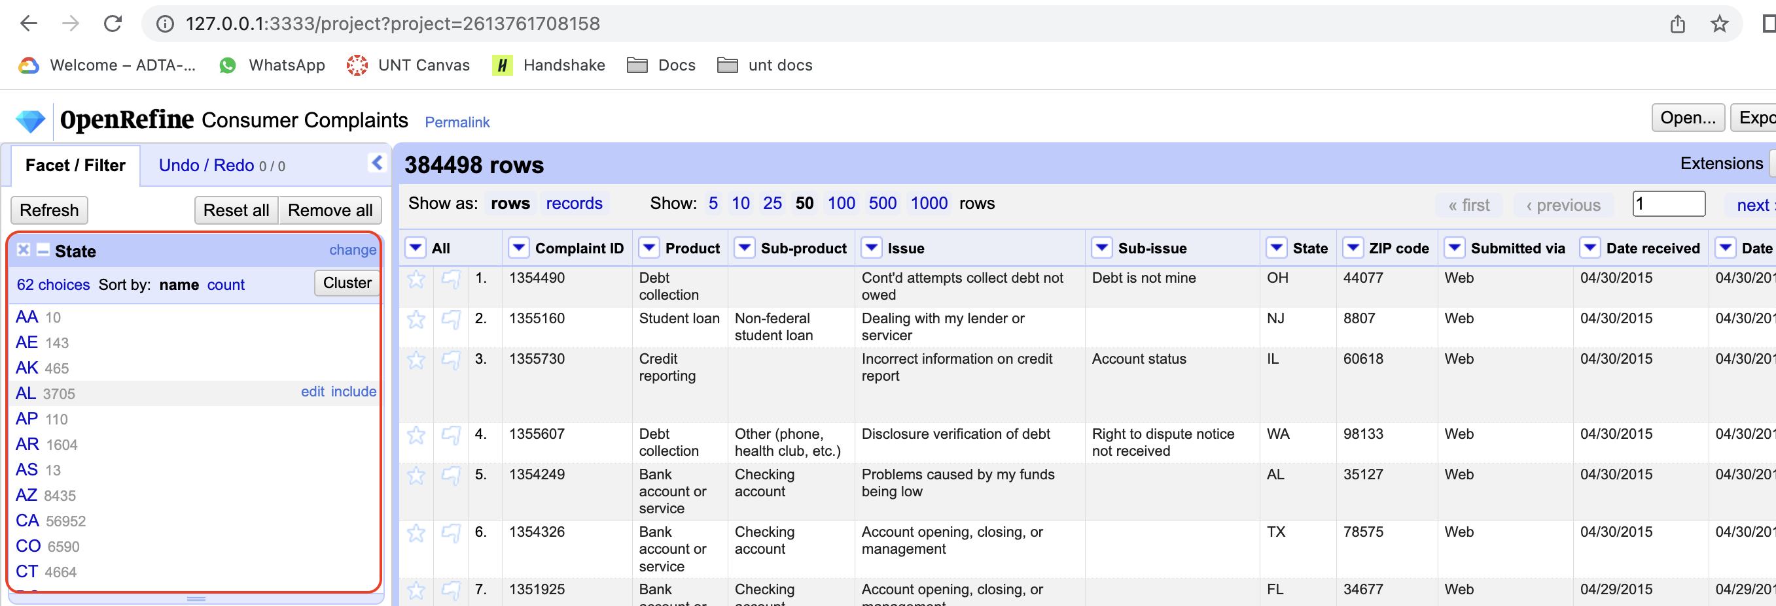

**Task 5: numeric facet**

At the column ZIP code, click on the dropdown, select facet and thn click on numeric facet.

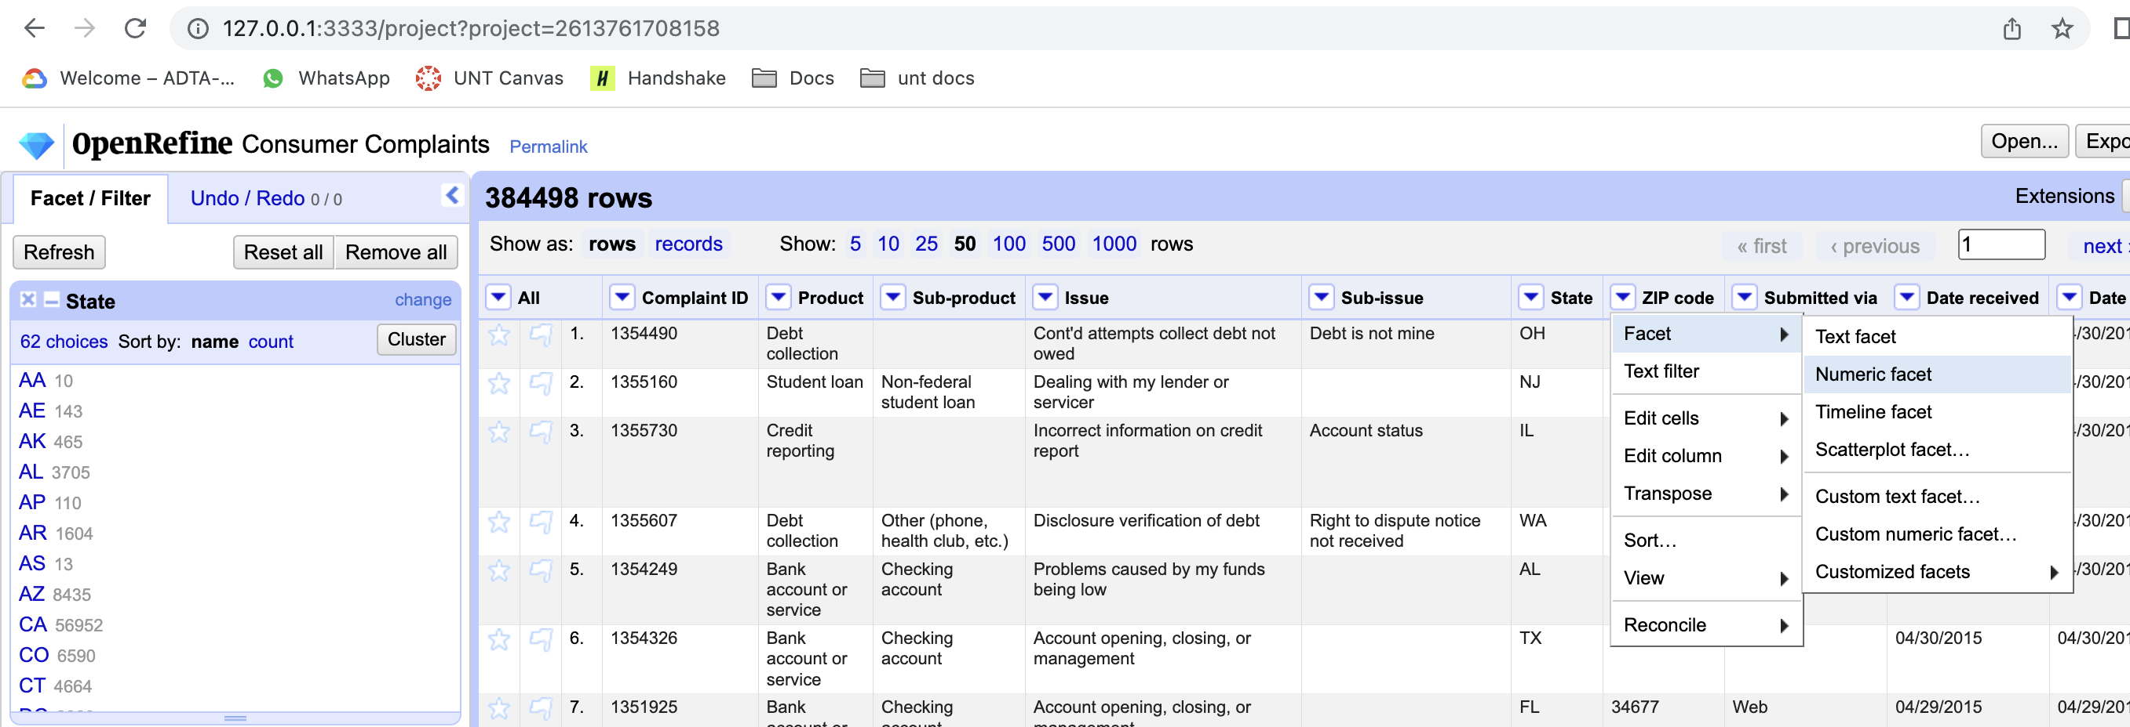

The values in the ZIP code column are in string format hence, we cannot populate values in the facet window.

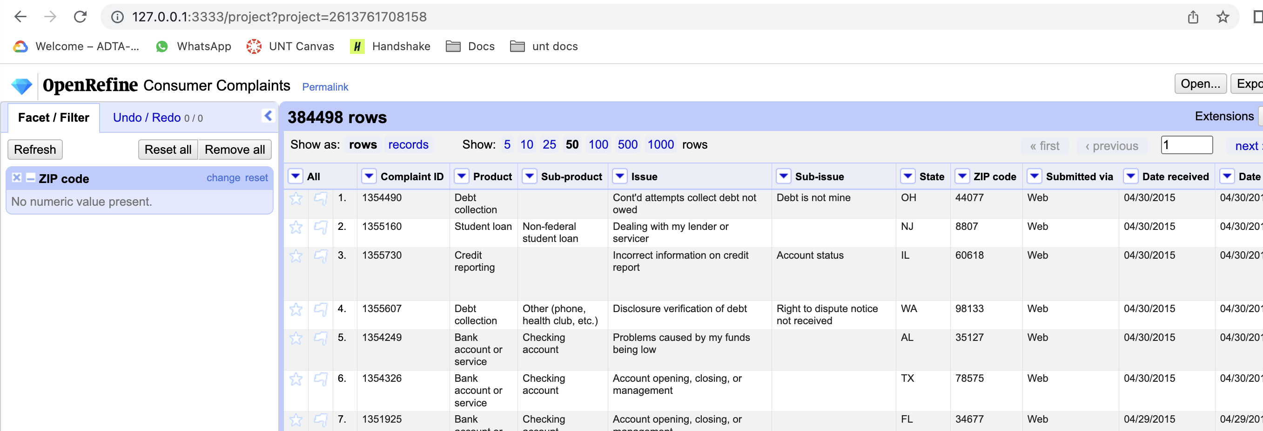

Because the values in the zip code are in string, we are now doing data wrangling operation by converting string data to numbers. Click on dropdown at ZIP code column, choose “Edit cells”, then choose “common transforms” and click on “To number”.

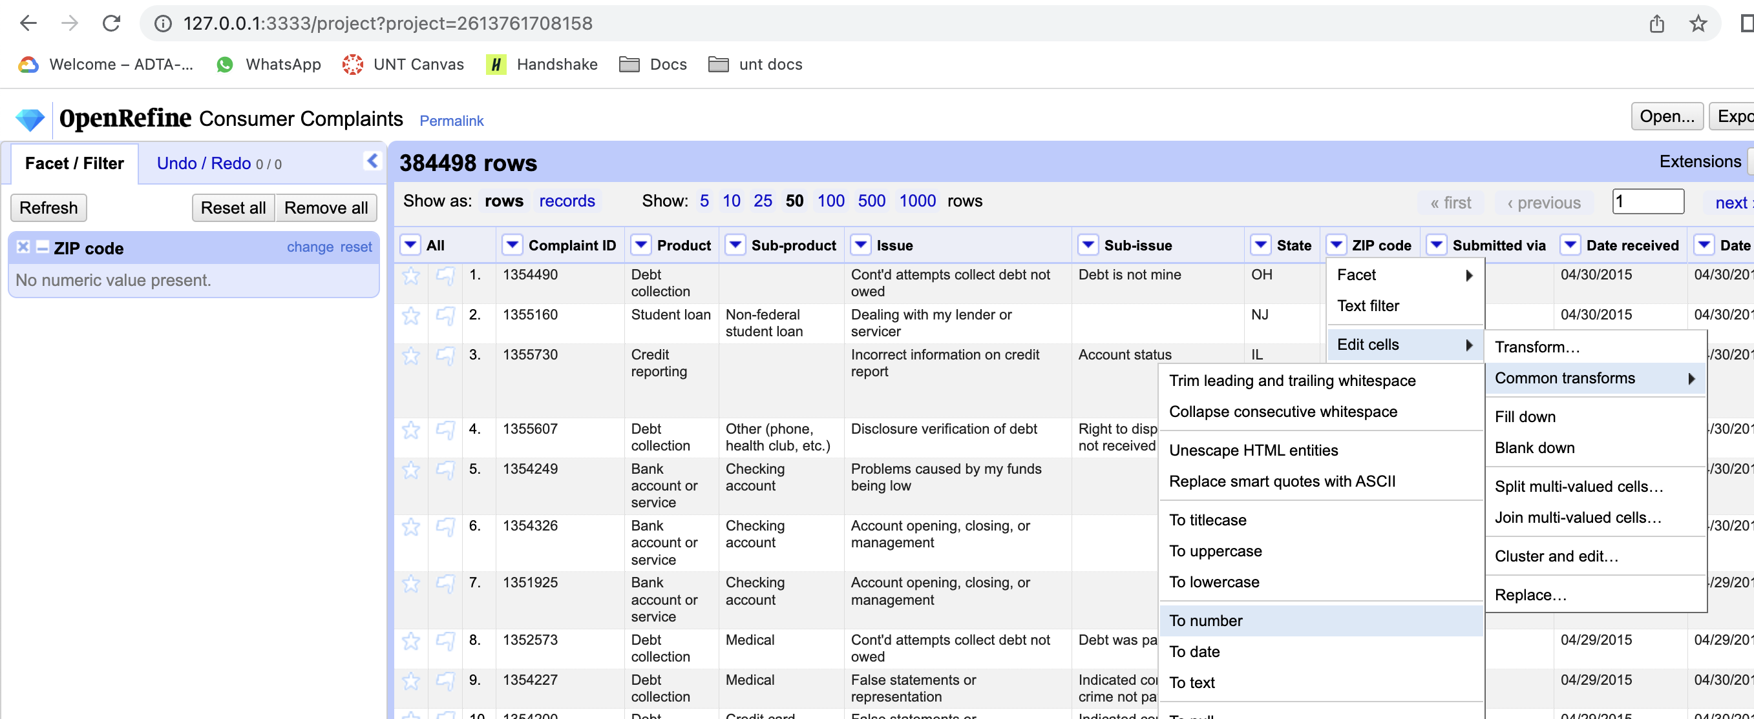

after a couple of seconds, you can see numeric values for ZIP code column, the window at the left hand side also updated with the numeric values 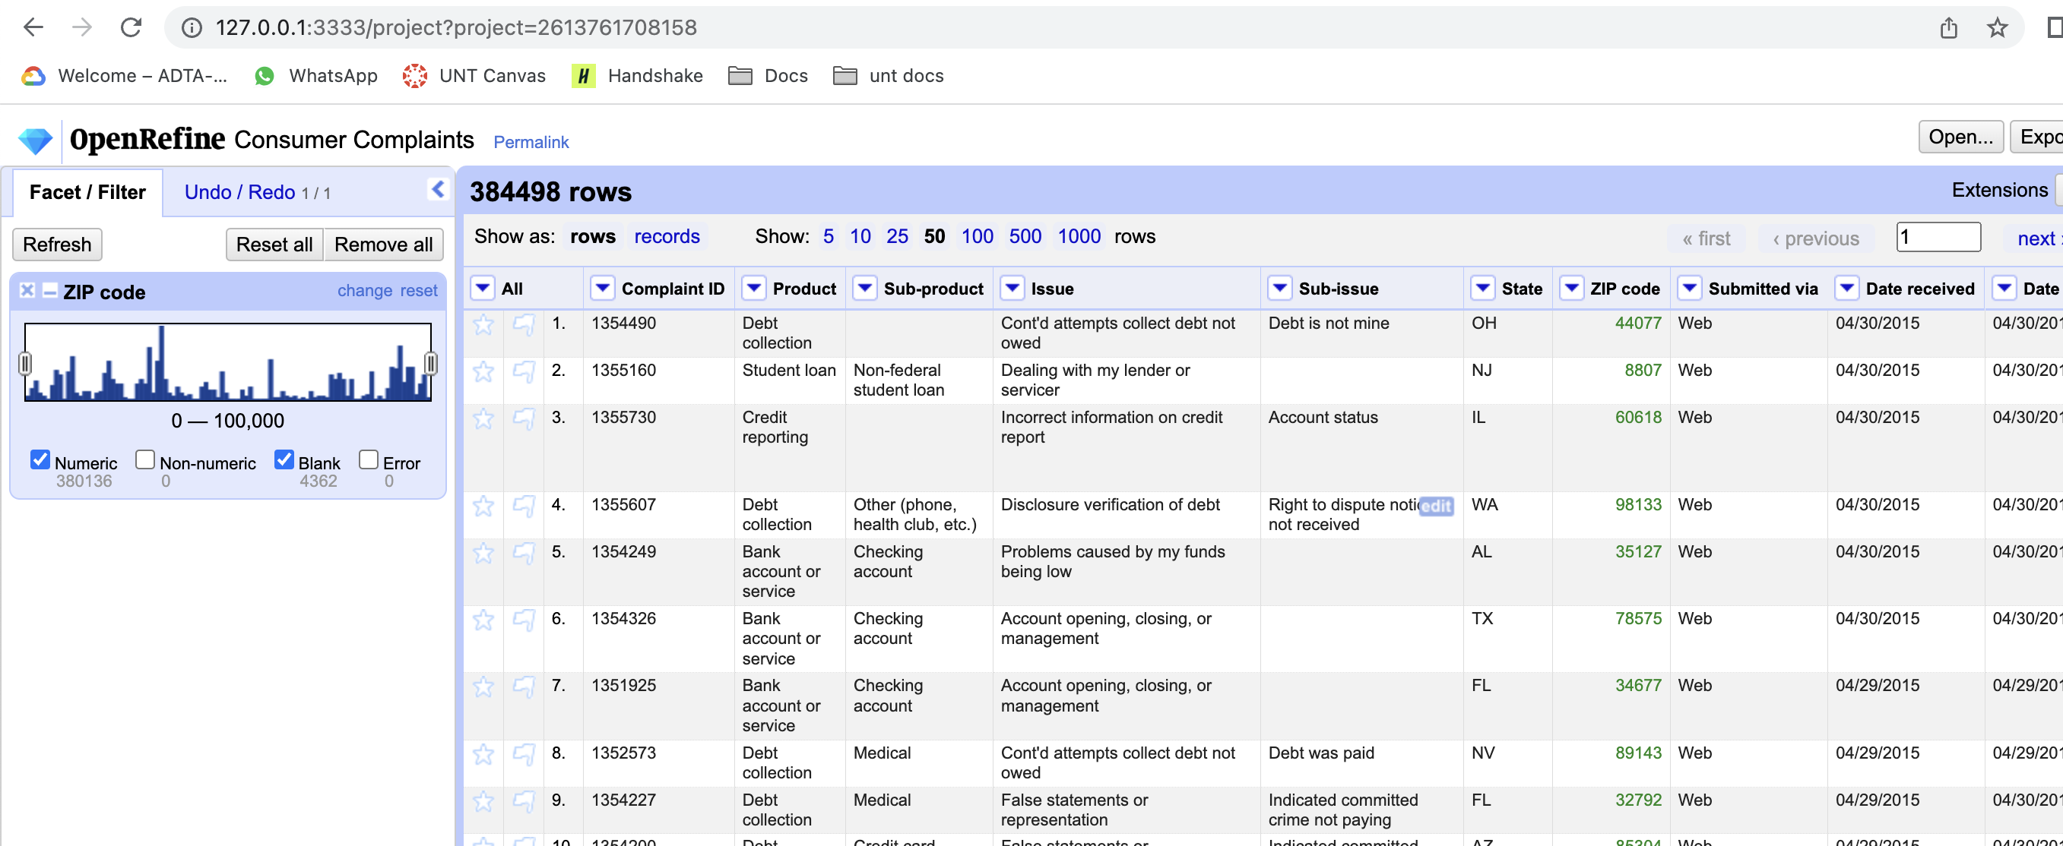

**Task 6: handling missing values**

After applying above step, if you go deeper into the data you would see few blank cells in that column

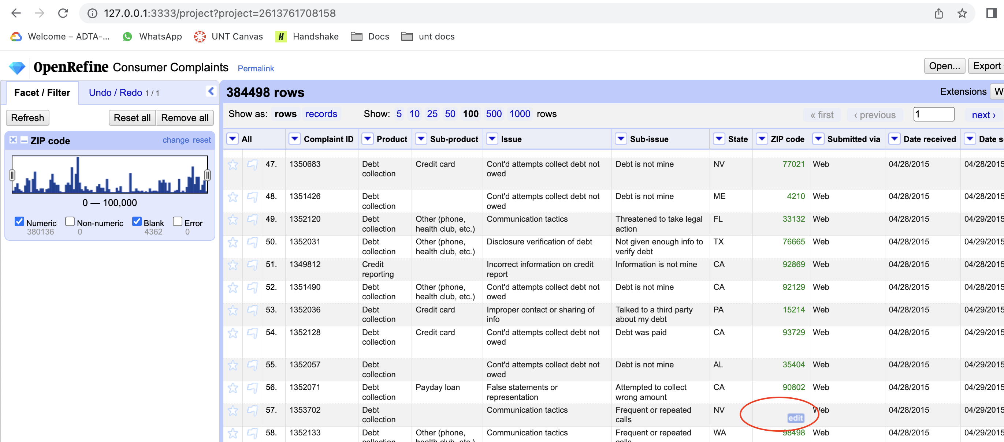

To overcome blank values in the cells, a new column can be created based on zip code and add values 99999 for all blank cells. to create new column, go to the drop down menu for zip code column choose “edit column” and click on “add column based on this column”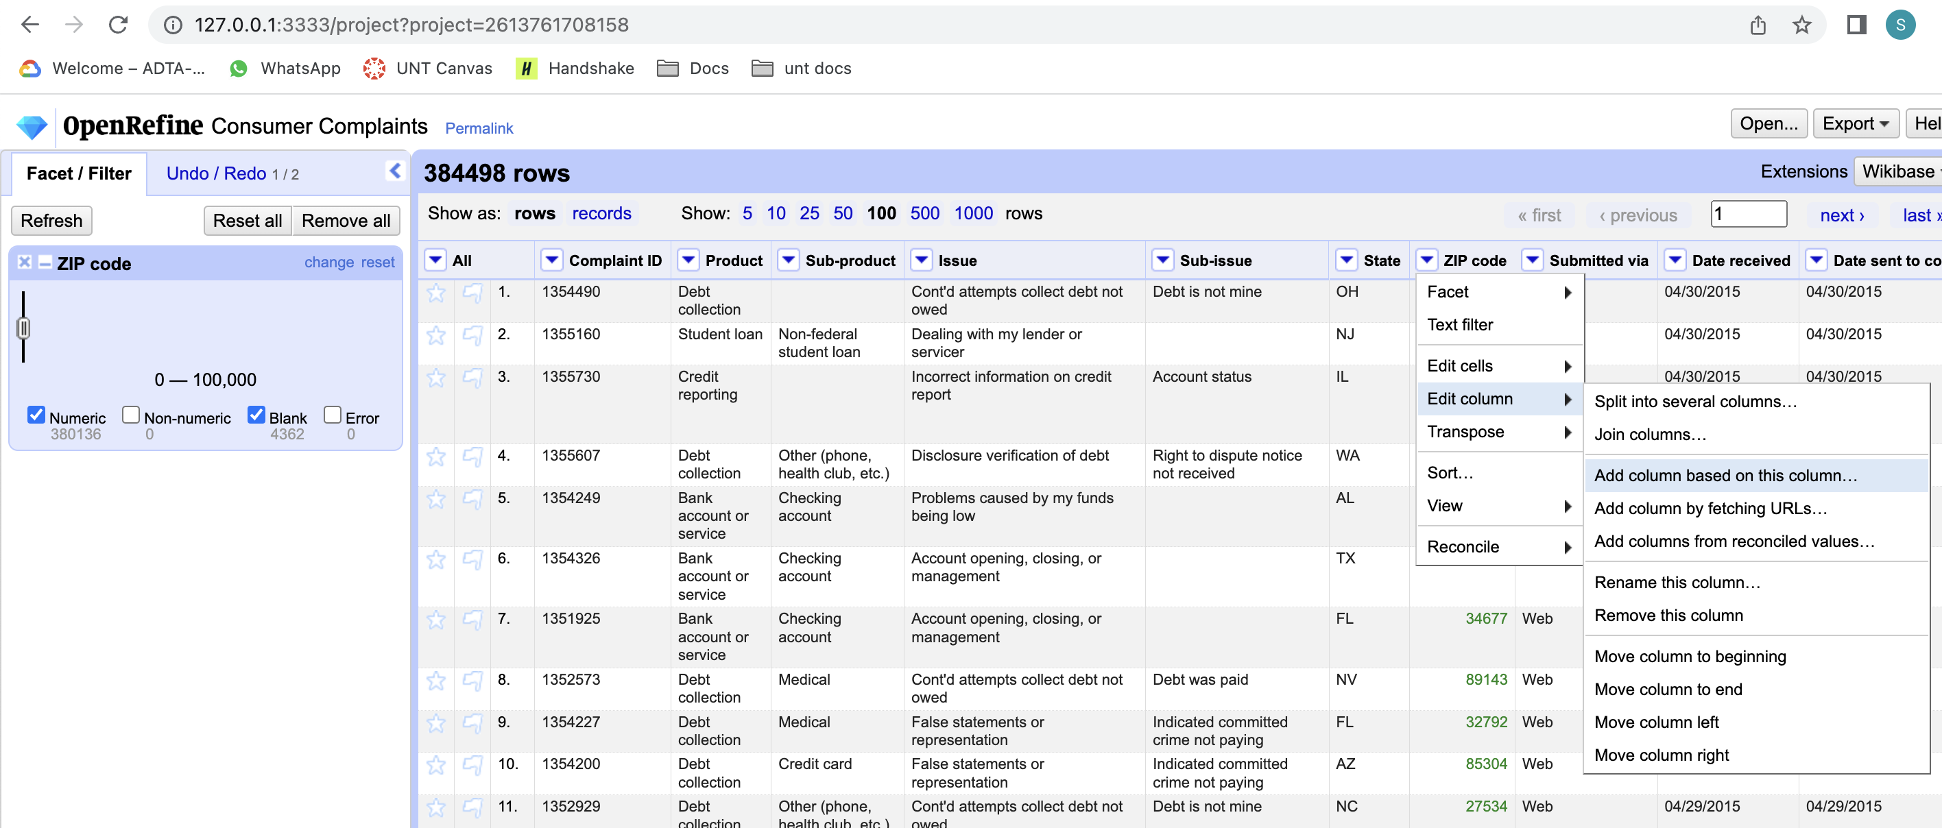

A new popup window opens here we can define expression based on the zip code column. You can also give name to the new column. click OK to apply.

Expression: if(value != null, value, 99999)

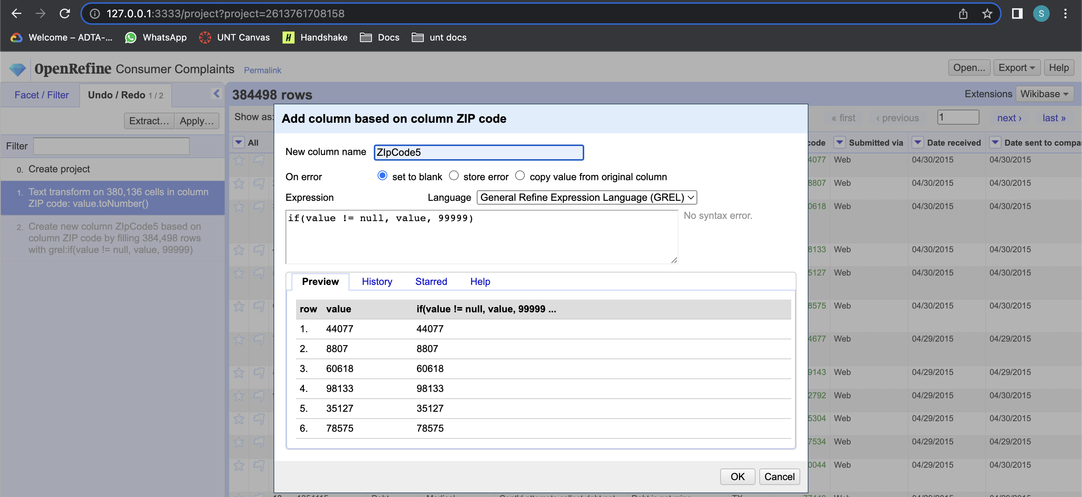

You can see the updated column

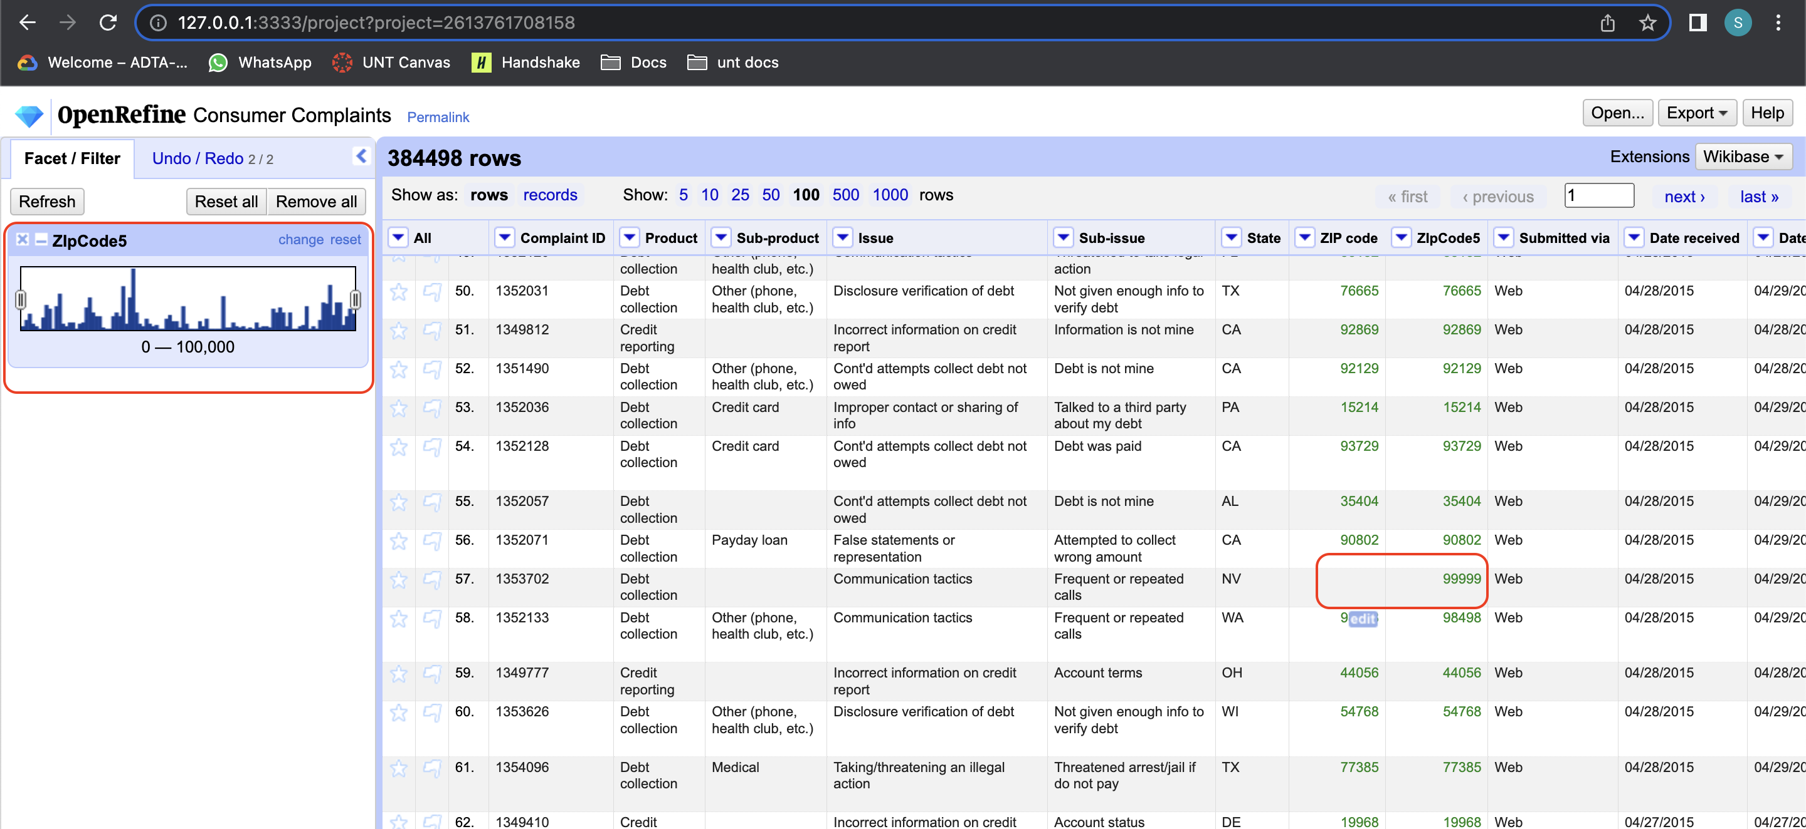

**Task 7: Cleaning and Wrangling data with new project**

Now, we are going to perform data operations on another dataset. Go to the homepage, create new project and upload eq_2015.CSV data.

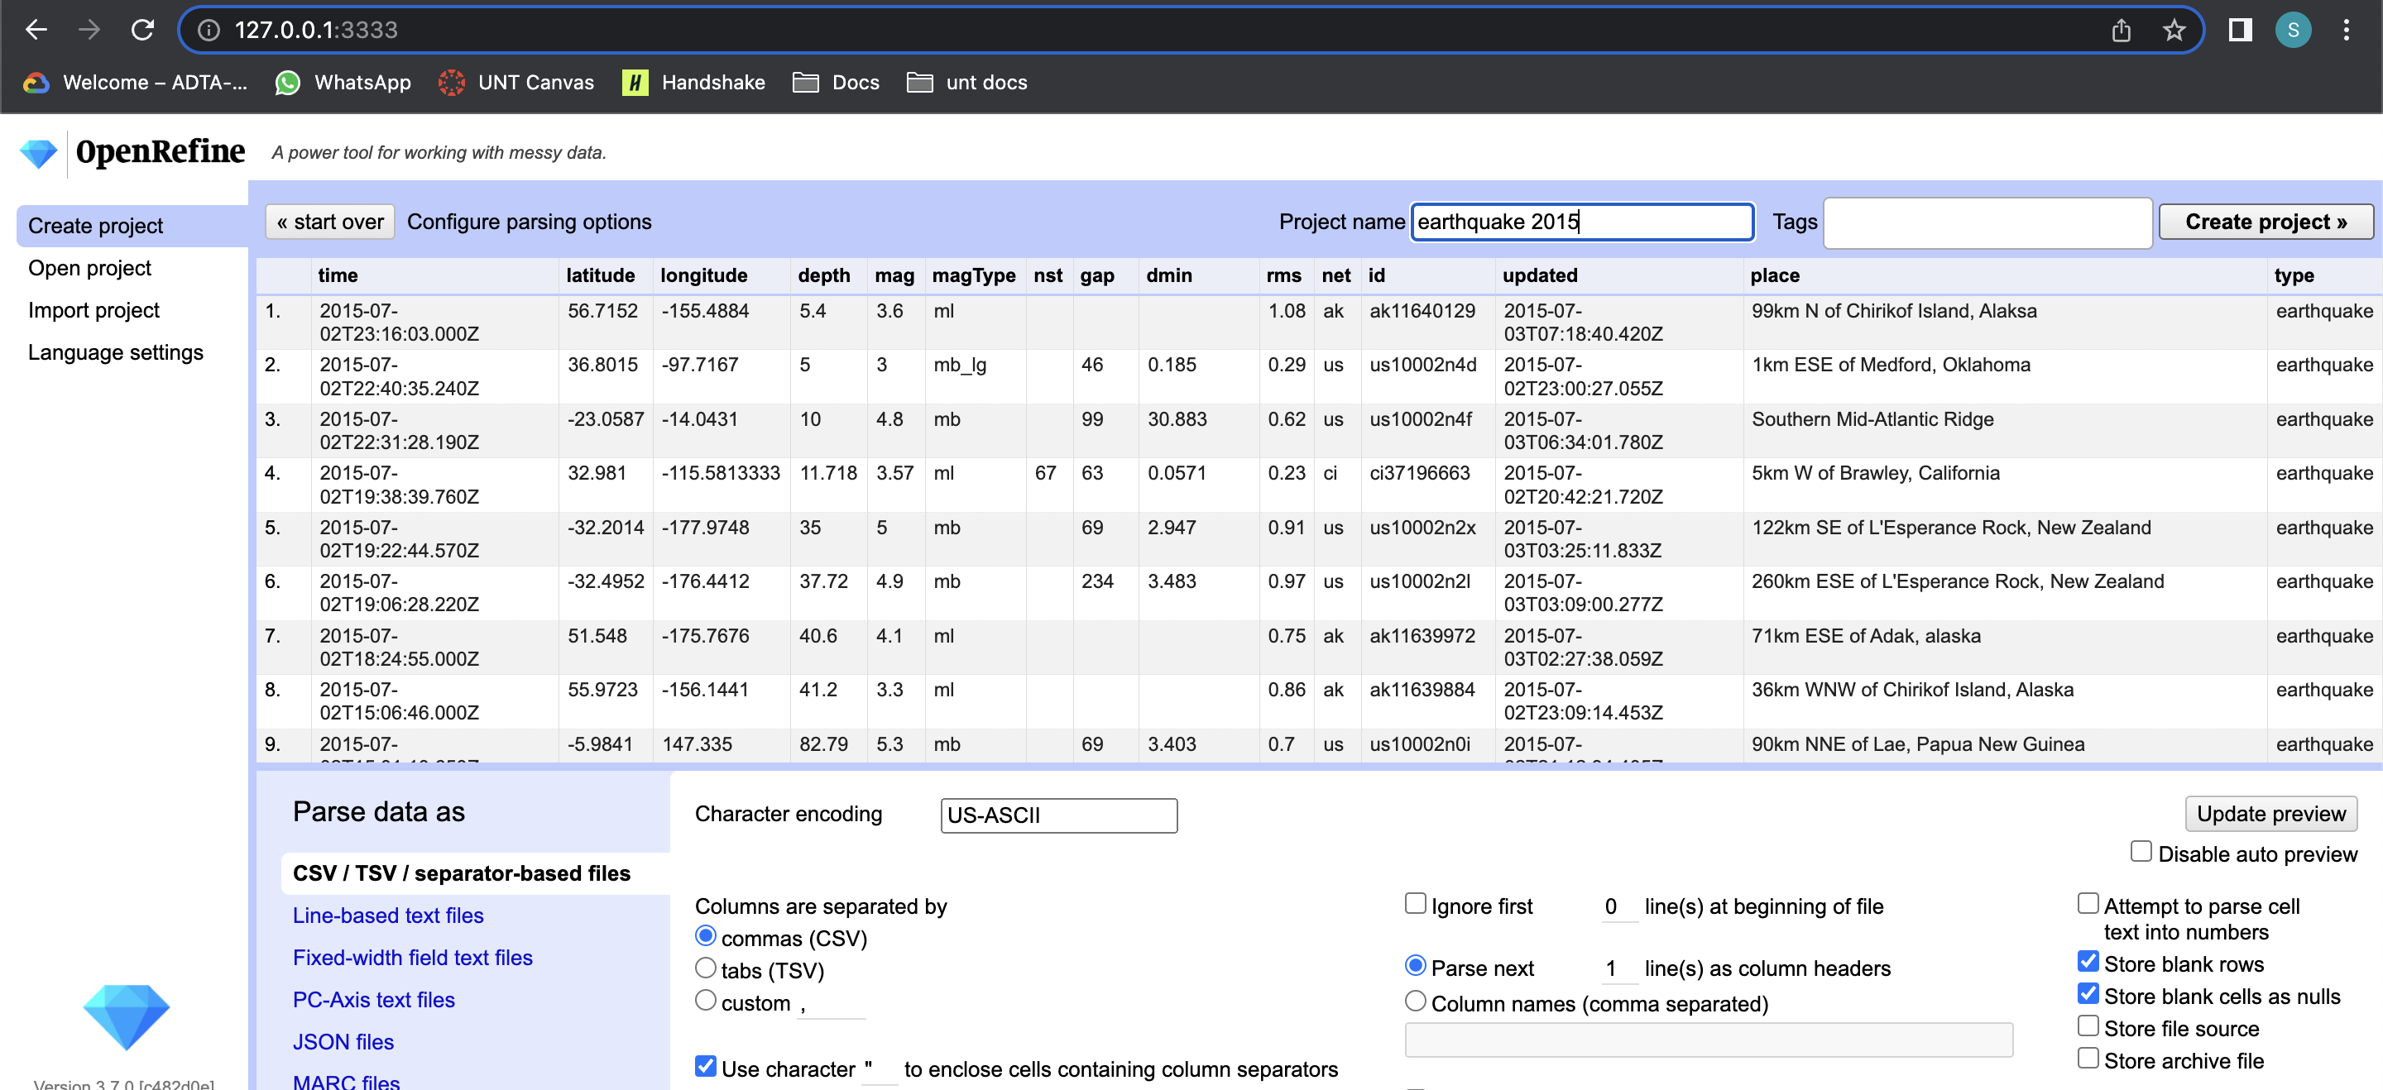

**Task 8: transforming the Place column:**

I need to add new column “location” from “Place” column. We need to put second substring of Place into the Location Column. You can refer formulae in the screenshot.

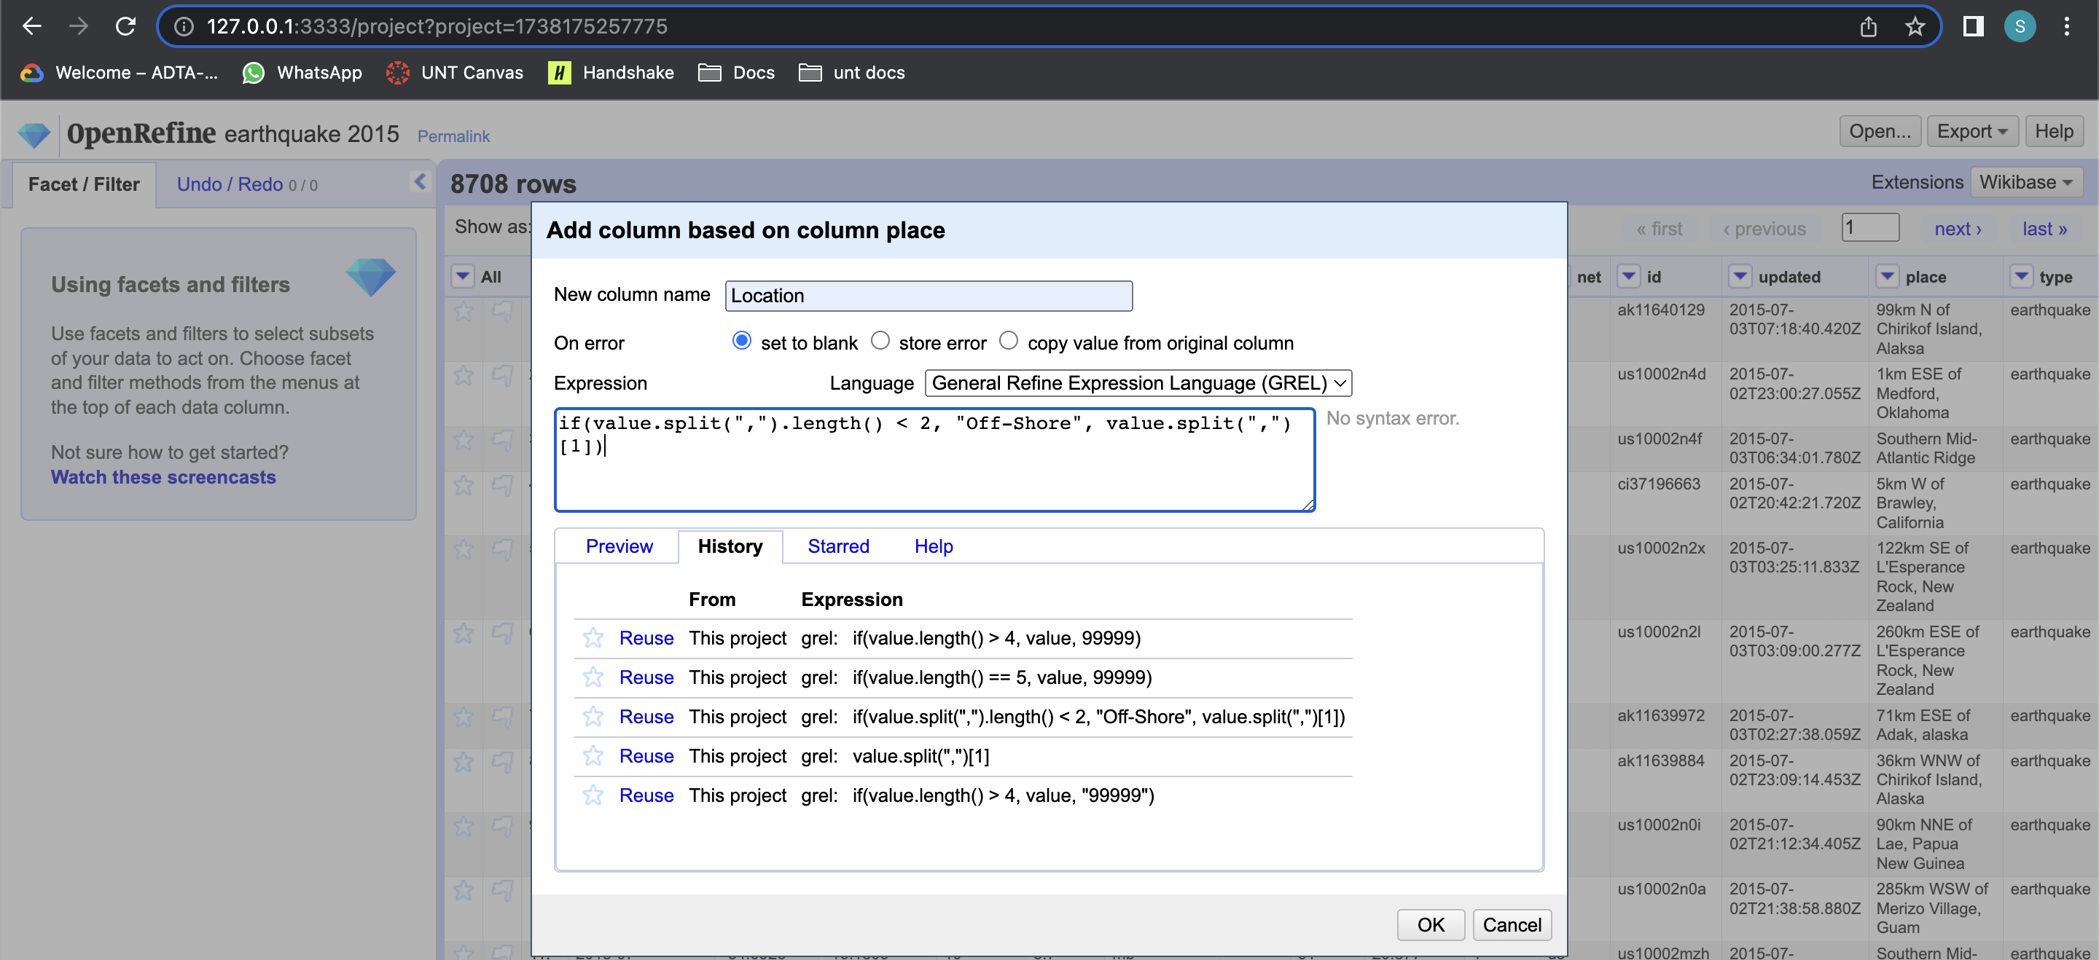

You can see below the newly created Location column.

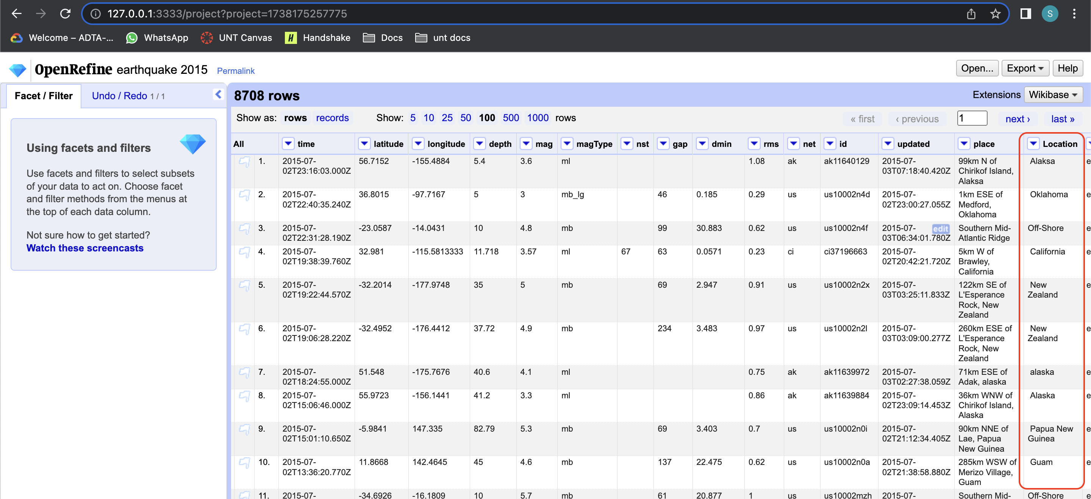

**Task 9: text Facet on Location Column**

To apply text facet on location column, click on dropdown button at location column, choose “facet” and click on “text facet”.

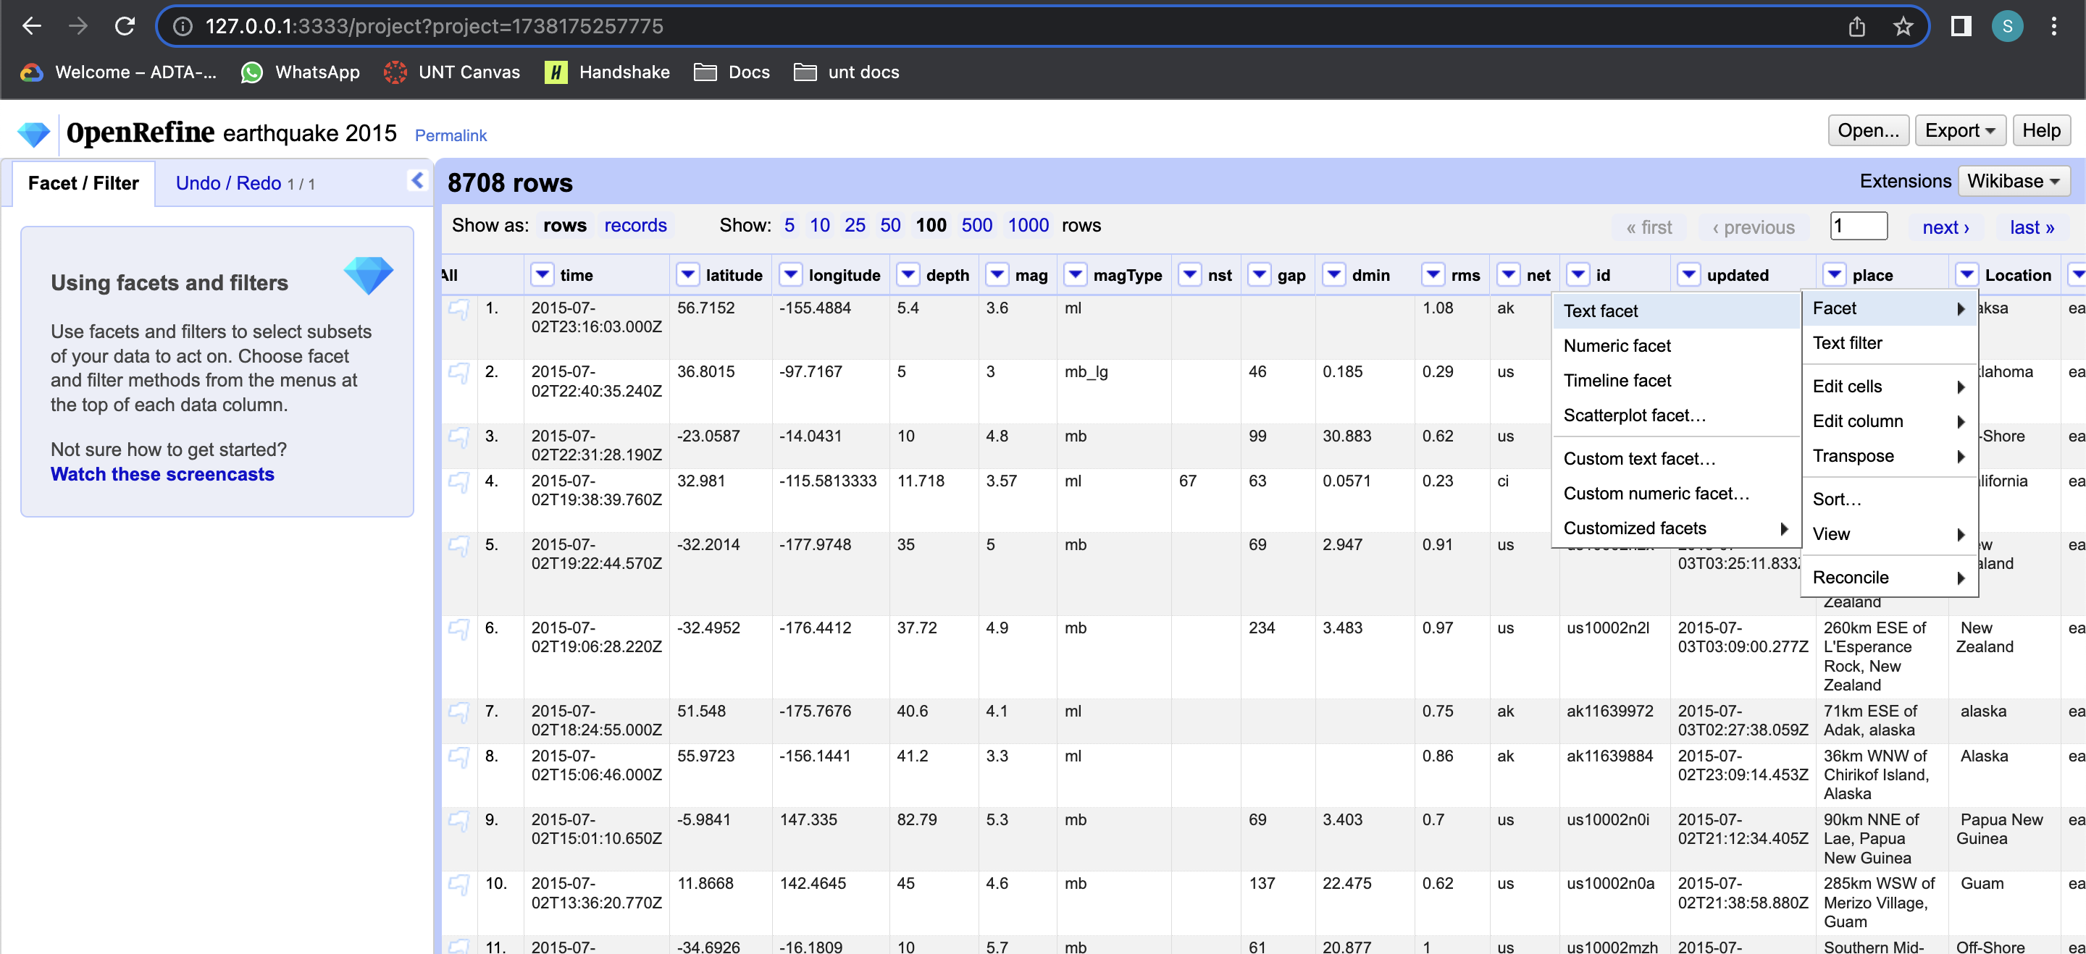

A new window appears on the left side of the screen showing the text facet of the data.

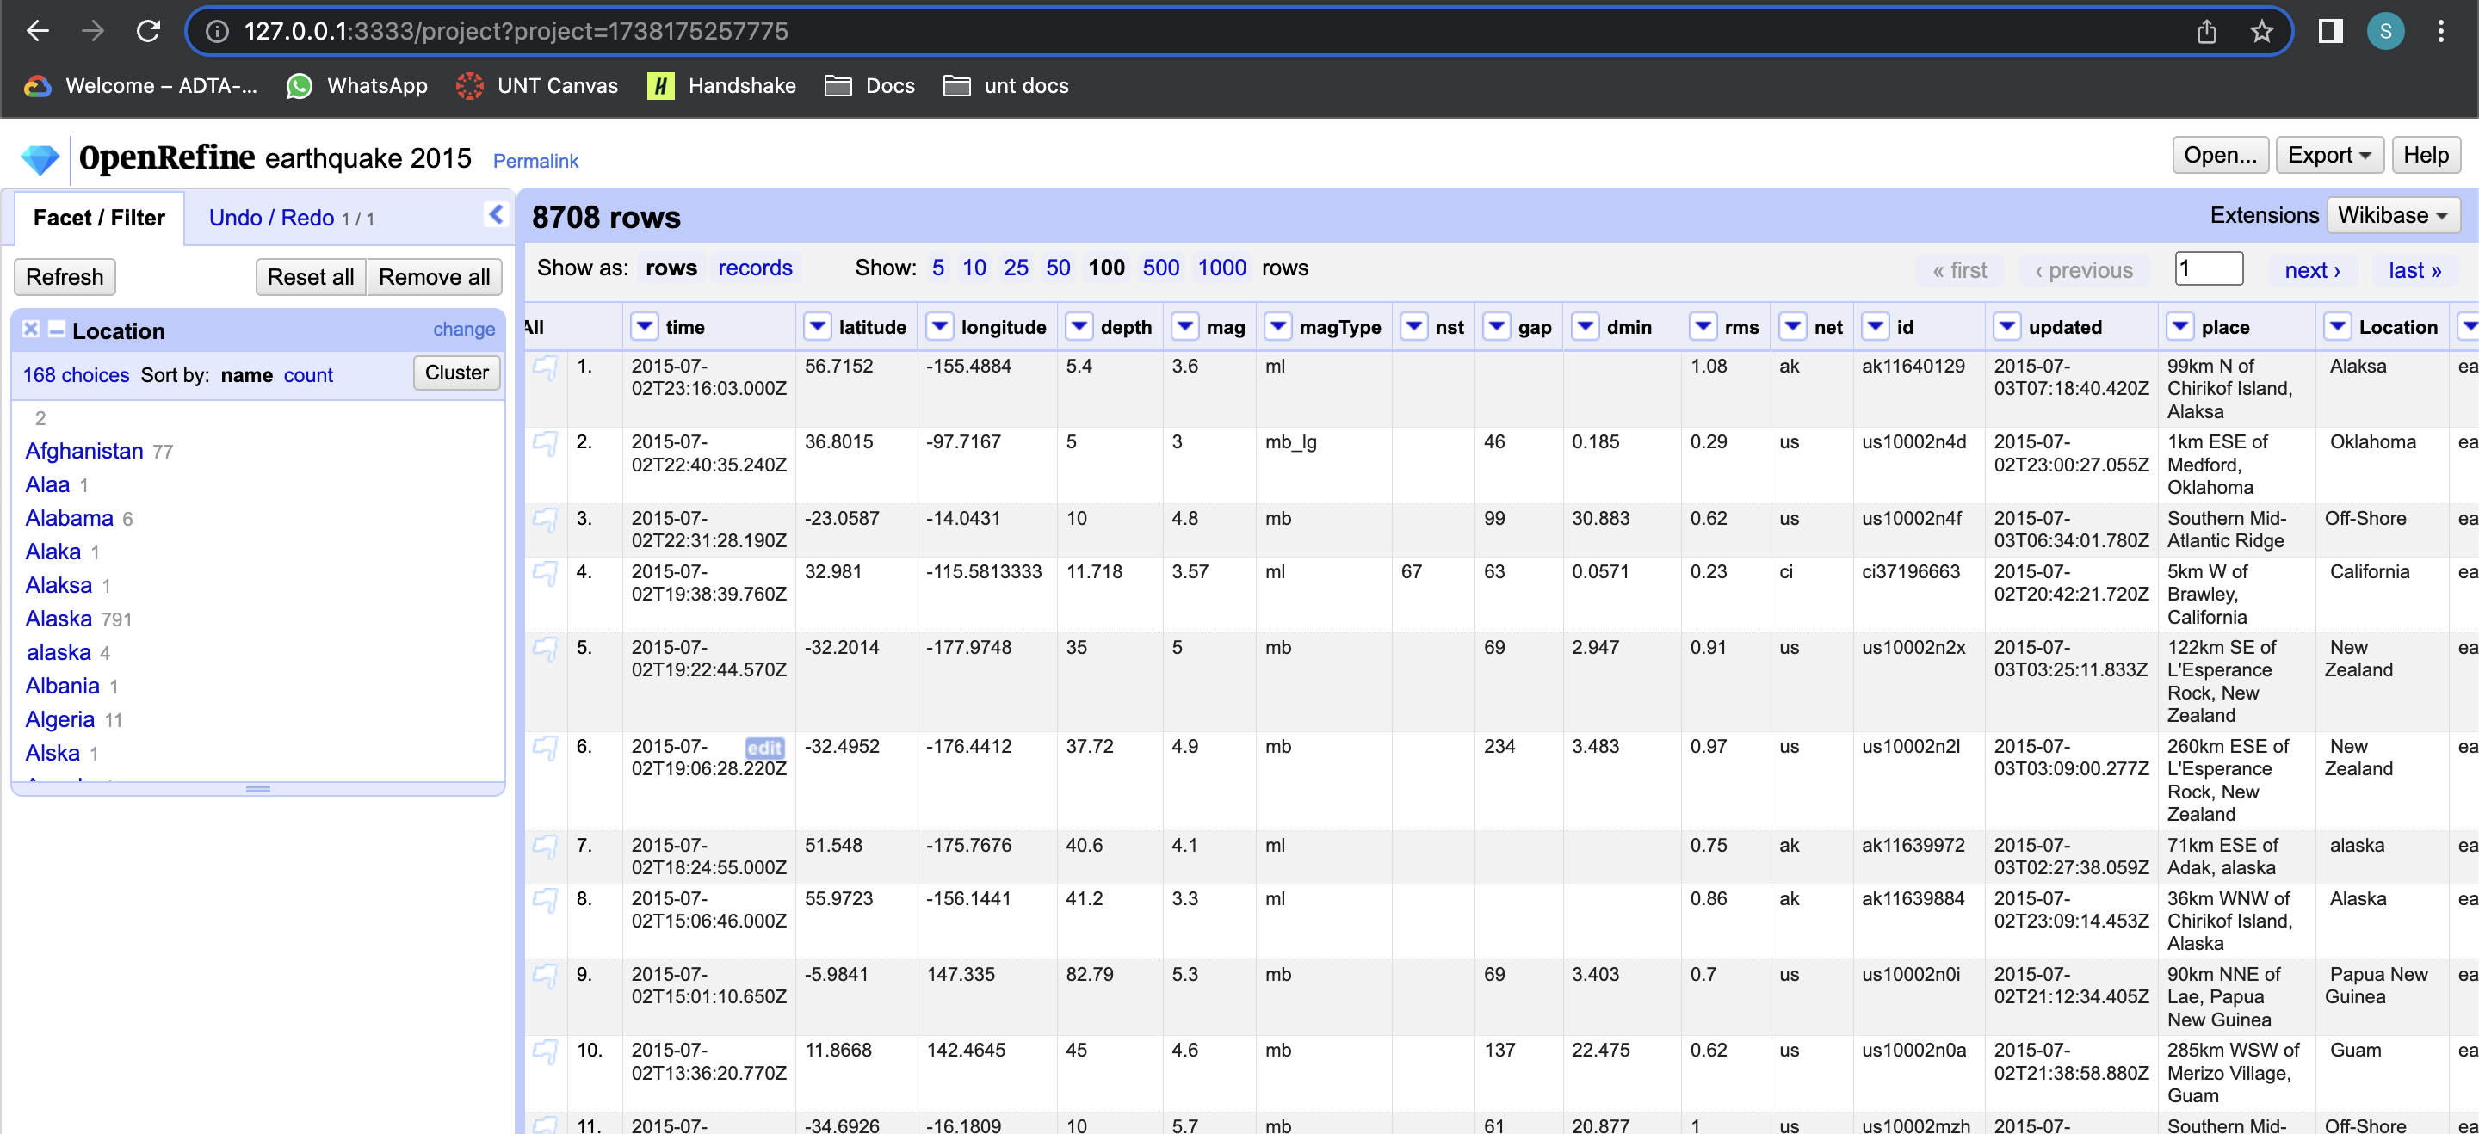

**Step 10: Clustering Location column**

You can see “Alaska” is wrong spelled in the Location column. we can see this happens for other data values as well in the same column. We need to clean this data by applying appropriate methods.

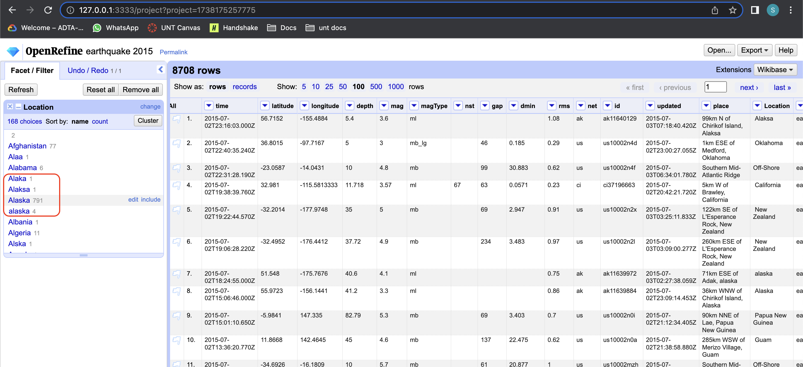

click on cluster at right side of the location text facet section. A new window opens wherein you can able to select different types of algorithms to patterns on the data.

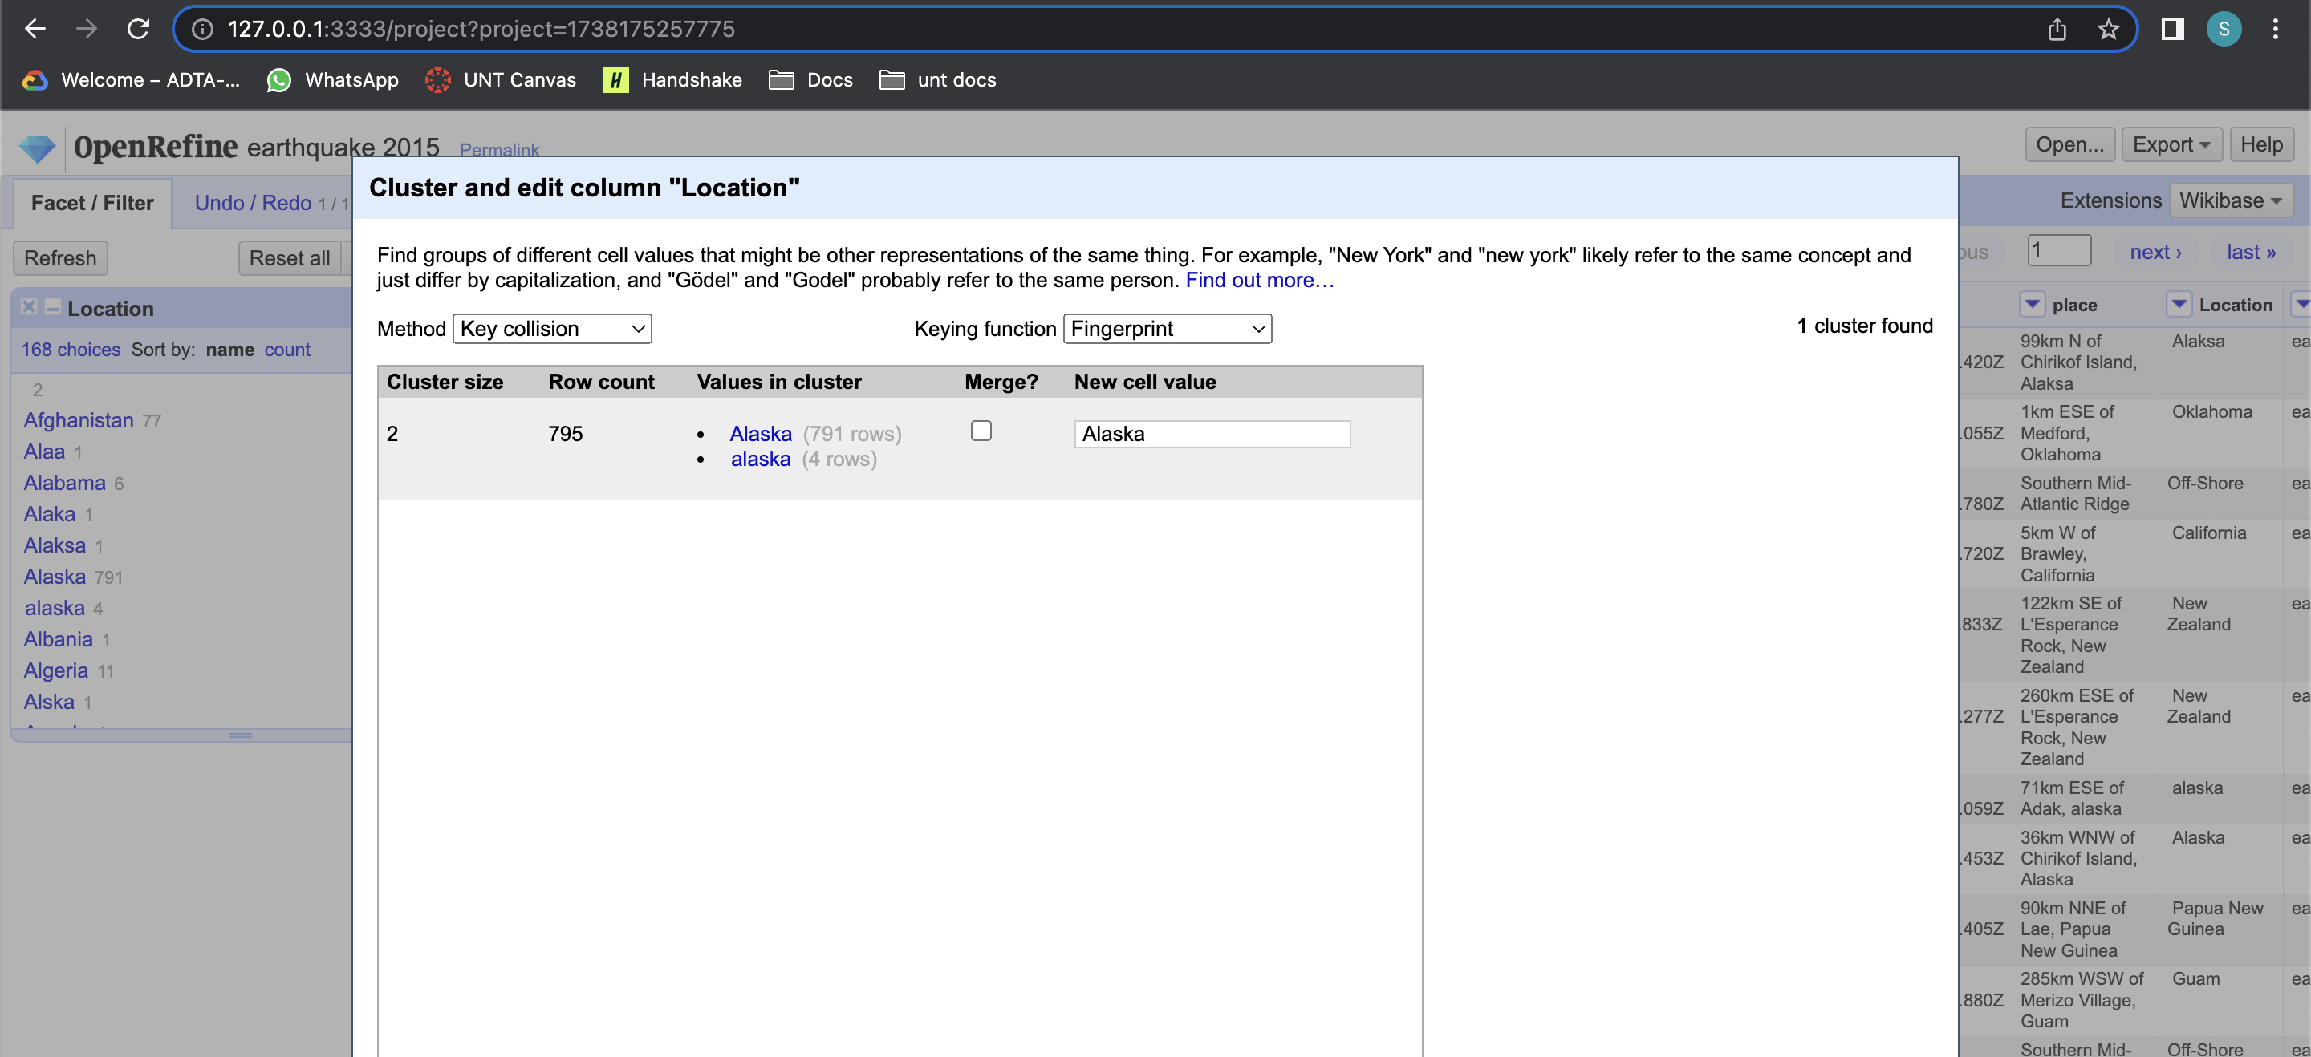

**Task 11: Applying merging algorithm:**

you can select different types of method name and keying function to select algorithm. Here, I choose method type as key collusion and keying function as metaphone3. Now you can select which values in the cluster need to be merged. Our data has problems at Alaska and California. So, I have selected check box at “Merge?” column for California and Alaska. After you choose which columns values need to be merged, click on “merge selected and re-cluster” button.

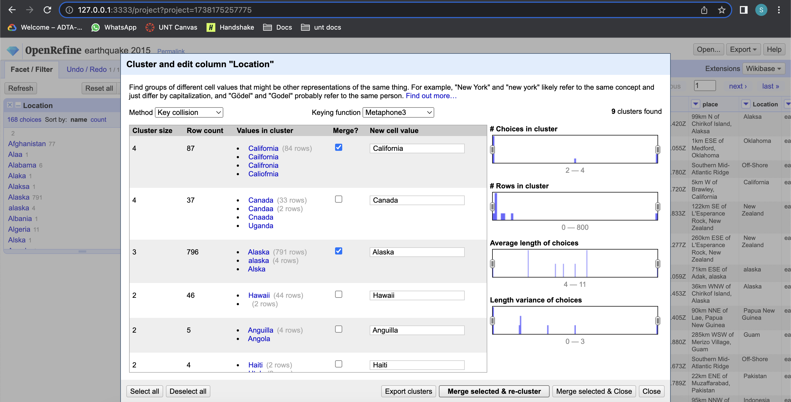

In the below screenshot you cannot see California and Alaska. Now, you can close the popup window.

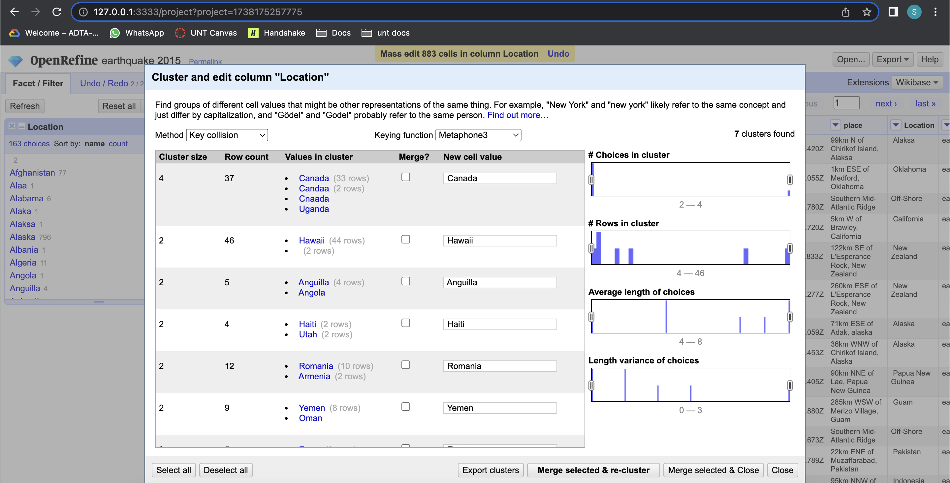

**Step 12: Manually editing cells in location column:**

After you apply text facet on the location column you still see some improperly spelled data. To correct this, we need to manually edit by going into each row.

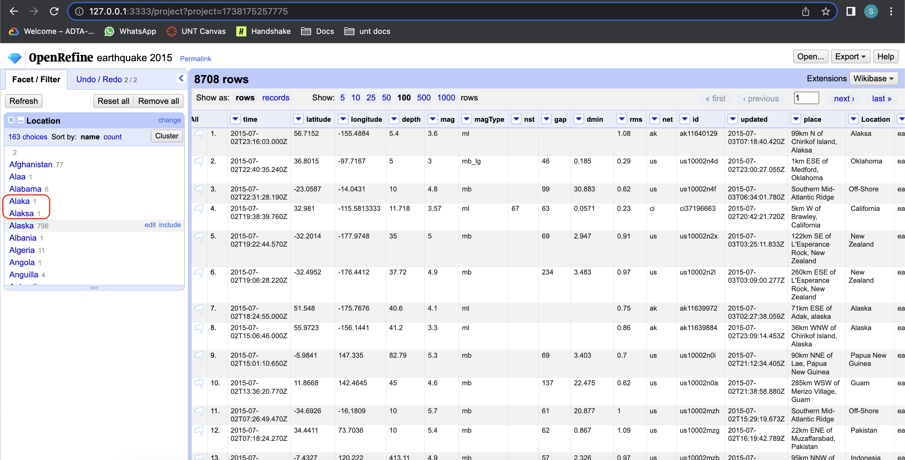

click on the misspelled name so that you can directly go to that row click on edit button visible at location column I type the correct value manually.

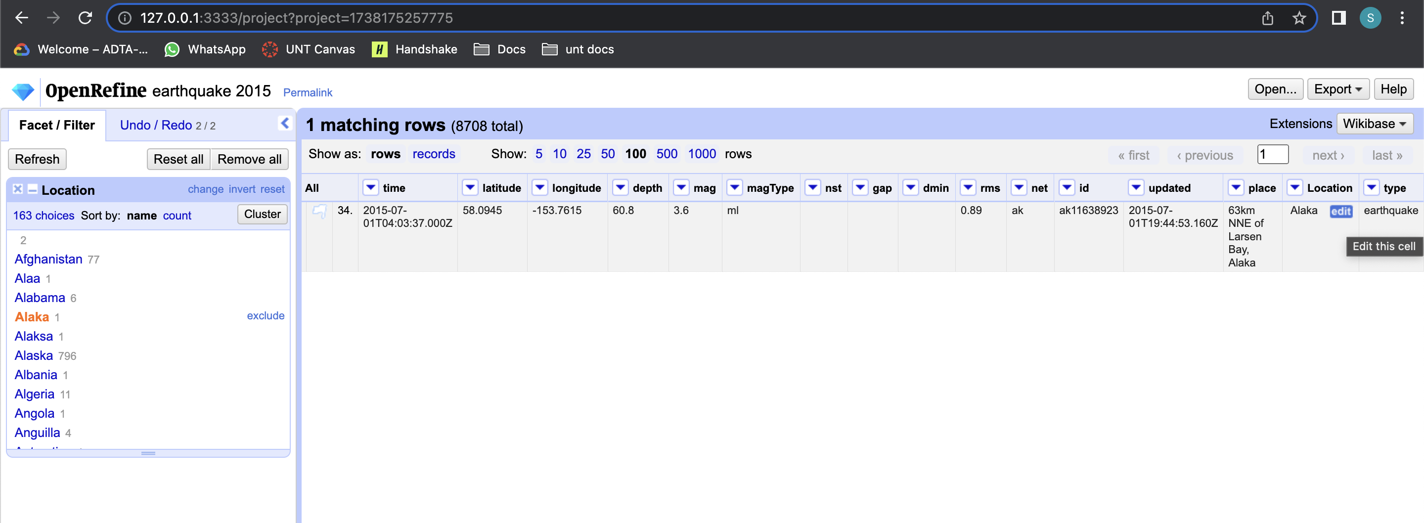

After you click on edit button, you can type the correct value and click apply button.

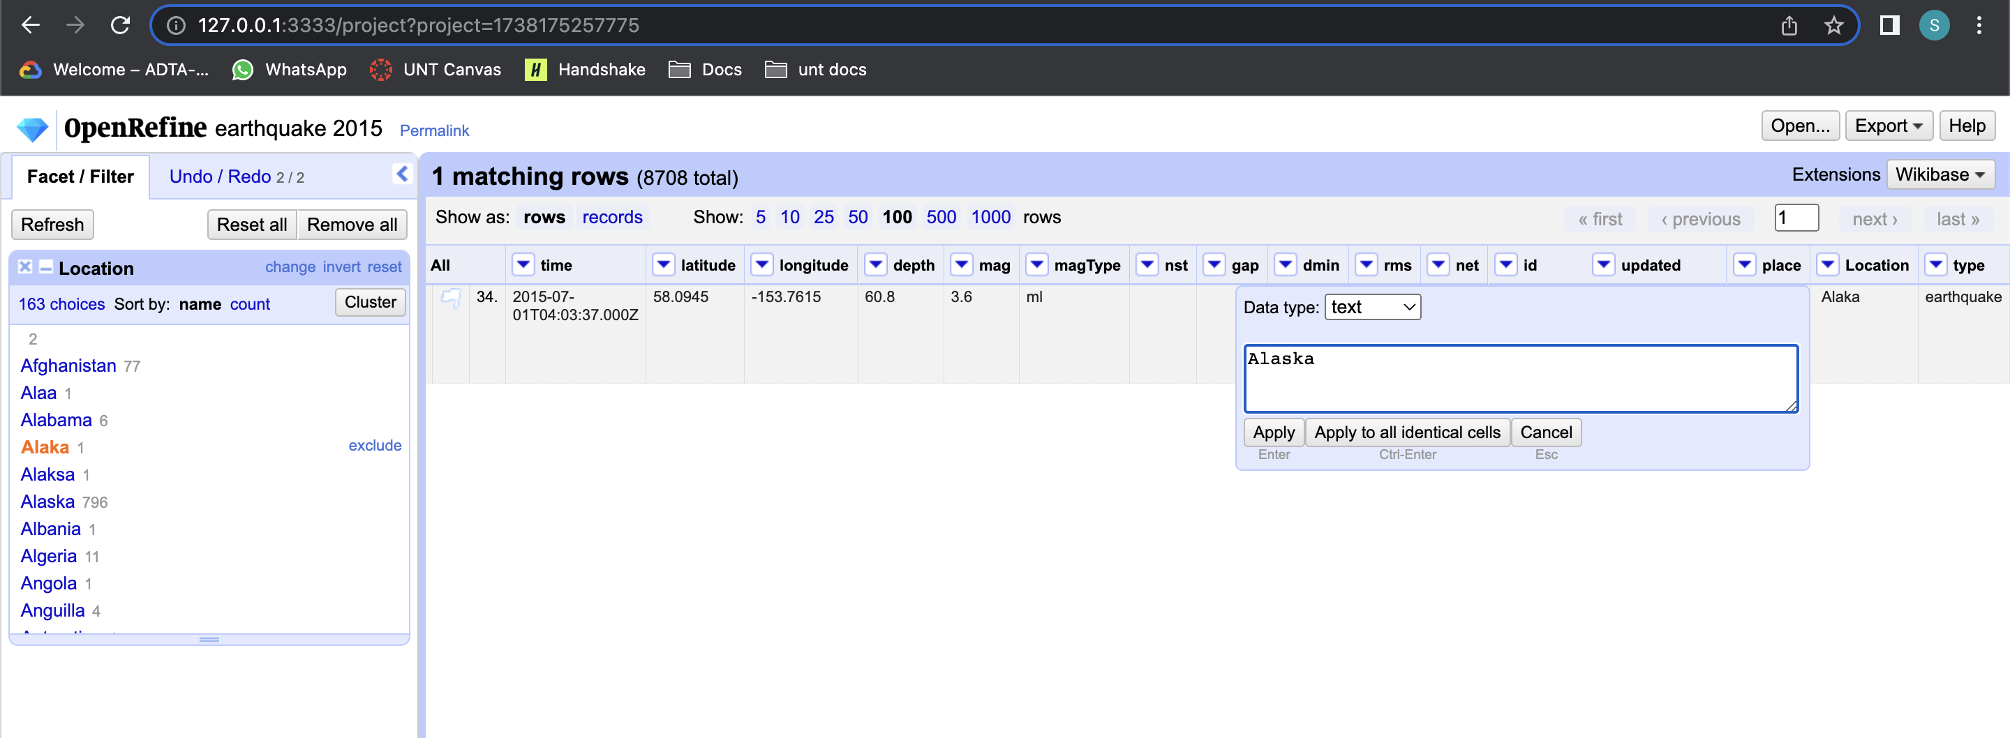

You can see the message at the top that edit has been successfully made and you can also see the updated value at the location column. Repeat the same procedure for all the incorrect values present in the location column.

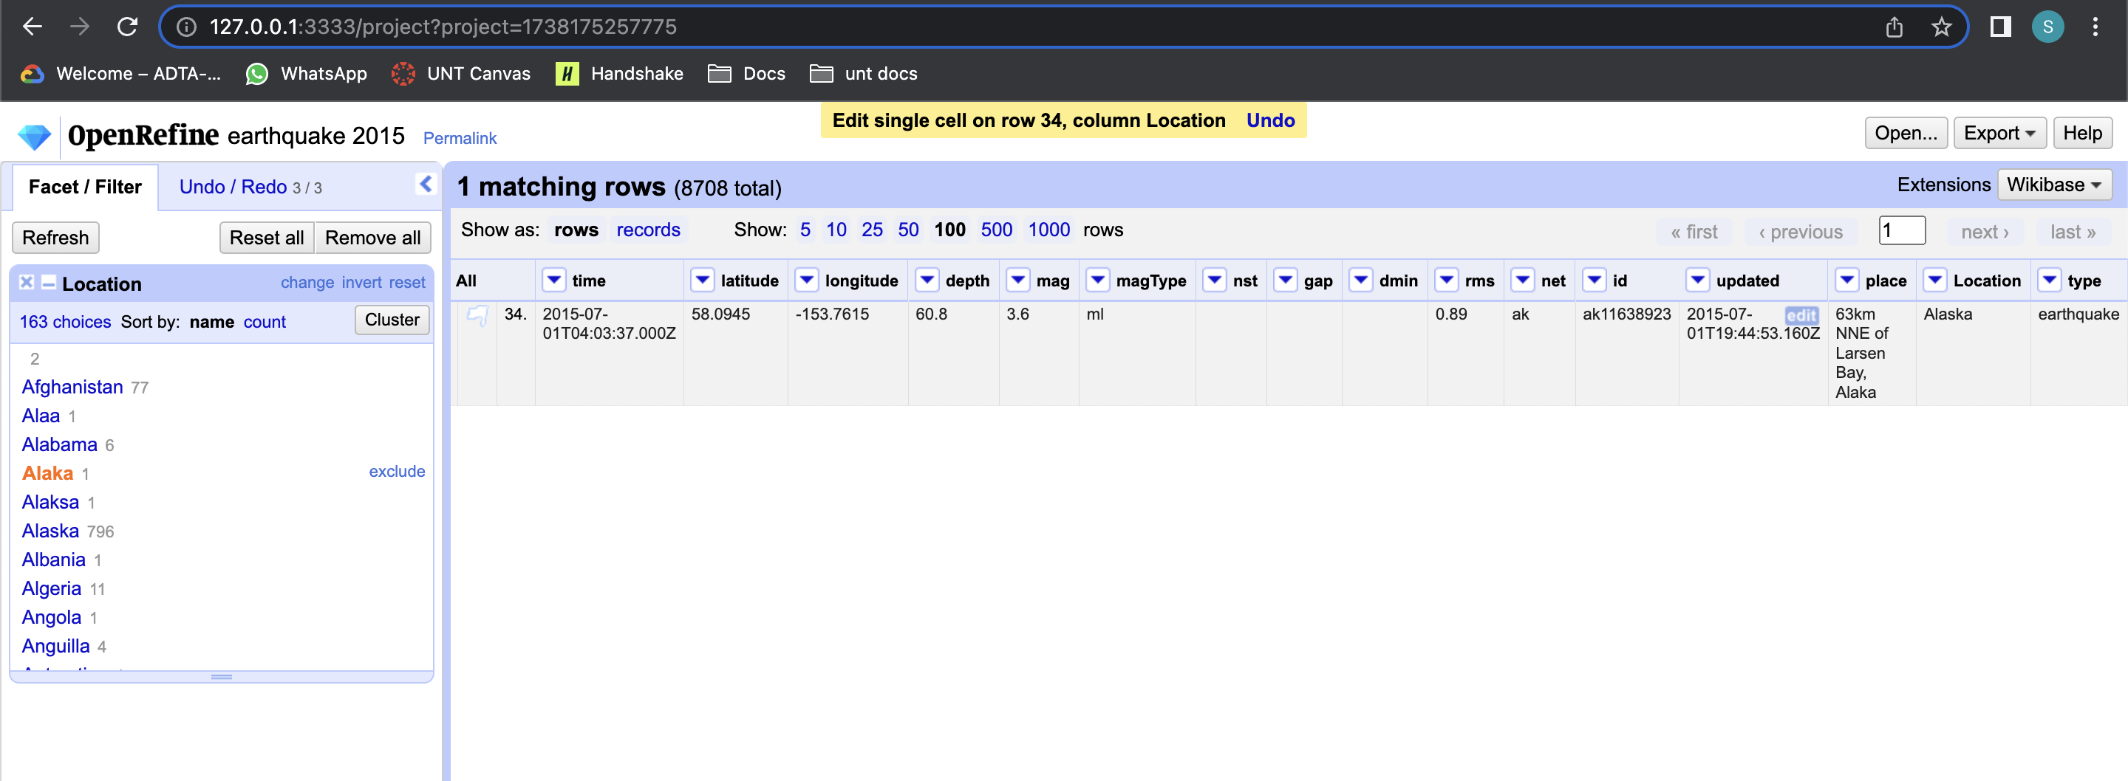

I have entered manually for all the incorrect values present. You can Verify the text facet on Location column. Data is clean for location column.

